

# ELECTRIFYING HOY ISLAND

**MSP Challenge**

**Group 4 as Community Group Representatives,**

**Group 5 as Conservationist Representatives,**

**Group 6 as Energy Developer Representatives**

***Creating a marine plan for electricity cabling between mainland Scotland and the surrounding island (Hoy) to ensure the new cabling development project would not impact any sensitive marine area.***

**Final Group Project**

**Prepared for: Susan Romeo-Gilbert**

**Jaismine Kaur (100186158)**

**Course Name: BCPT 404 7A/7B (Advanced Business Analytics)**

**Spring 2025**

# Executive summary

This report presents a collaborative marine spatial planning project conducted by three stakeholder groups - the Renewable Energy Developers, Conservationists, and Community Representatives focused on delivering a sustainable, locally beneficial, and environmentally responsible energy solution for **Hoy Island**, specifically serving the community of **Brim**s in the Orkney Islands, Scotland. Using the Marine Spatial Planning (MSP) simulation platform, real-world geospatial data, and structured decision-making methods, the groups collectively assessed multiple renewable energy plans to provide electricity to Brims, which currently lacks access to a reliable energy supply.

The core **problem statement** guiding this project was:

**“How can we provide Hoy Island with a clean, resilient, and technically feasible source of electricity while minimizing conflict with marine protected areas, local fishing industries, and essential shipping lanes?”**

Through an inclusive and analytical approach, the three groups evaluated four primary alternatives, including:

1. **Actual Plan:** A direct undersea cable from Gills Bay (mainland Scotland) to Brims.
2. **Alternative 1:** A new 50 MW tidal farm located near Brims with a short cable to shore.
3. **Alternative 2:** Routing electricity from existing mainland tidal farms through Burwick and Herston to Brims.
4. **Alternative 3 (Preferred Plan):** A wave energy farm offshore from Outer town, transmitting power through Murra to Brims via a 4.98 km cable.

Each plan was rigorously assessed using criteria such as environmental impact (MPAs, fishing zones, shipping lanes), infrastructure complexity, cost-effectiveness, and energy autonomy. The stakeholder groups brought unique priorities to the decision-making table:

* **The Community** prioritized energy independence, economic development, affordability, and minimal disruption to fishing livelihoods.
* **Conservationists** emphasized the protection of marine biodiversity, avoidance of MPAs, and minimal disruption to seabird and marine mammal habitats.
* **Developers** focused on technical feasibility, infrastructure efficiency, regulatory compliance, and long-term sustainability.

Following detailed spatial analysis and stakeholder simulations, **Alternative 3 was selected as the best consensus plan**. It avoids all MPAs and high-conflict marine zones, provides full energy autonomy to Hoy Island, is technically feasible, and aligns with Scotland’s marine renewable energy development goals. Although it requires moderate infrastructure investment, the long-term ecological, social, and operational benefits far outweigh those of other plans.

The report also outlines structured decision-making (SDM) processes, technical assessments, stakeholder perspectives, cost implications, environmental reviews, and implementation recommendations. The project concludes with a multi-stakeholder endorsement of Alternative 3 as the preferred route forward, and a roadmap for permitting, construction, monitoring, and community integration.

This initiative demonstrates the power of inclusive marine spatial planning in balancing development needs with environmental responsibility and local values. The Hoy Island project serves as a model for future renewable energy planning in sensitive marine environments.

# Table of Contents

ELECTRIFYING HOY ISLAND 1

Executive summary 2

Table of Contents 4

Introduction 5

Methodology 5

Overall Findings 6

Alternative 3: Wave Farm near Outertown with Routing via Murra to Brims 6

Community Perspective on Alternative III 7

Conservationist POV – Alternative III 9

Recommendations 11

Conservationist Recommendations: 13

Developers Recommendations: 14

Conclusion 14

References 15

Appendices 16

Developer Group Report Hoy Island Energy Access Project 16

Actual Plan: Direct Undersea Cable from Gills Bay to Brims (Hoy Island) 17

Alternative 1: Tidal Farm Installation Near Brims (Hoy Island) 19

Alternative 2: Using Existing Mainland Tidal Farms via Island Hopping Cable Route 23

Analysis of 5 Key Developer Questions 31

## Introduction

Hoy Island, part of the Orkney archipelago in northern Scotland, is known for its rugged coastline, deep maritime history, and small but resilient community. As renewable energy infrastructure continues to expand across the UK, marine regions like Hoy are becoming important points for development. Our plan as a group is to install an energy cable project linking mainland Scotland to Hoy. This report investigates the project from the perspective of various stakeholders, examining how changes to the marine environment may intersect with the lives, activities, and long-term interests of the people living on and around Hoy Island.

## Methodology

This report draws from a variety of data sources to provide a well-rounded community perspective on the proposed energy cable project:

1. **MSP Challenge 2050 Simulator**: Most of our information is informed by the Marine Spatial Planning (MSP) simulation game, which started as a board game and evolved over the past decade into a decision support tool for planners. We used the provided core marine spatial planning data, including fishing zones, shipping routes, bathymetry, protected areas, and infrastructure overlays.
2. **ArcGIS Layers**: ArcGIS is a comprehensive geospatial platform, or Geographic Information System (GIS), developed by [Esri](https://www.esri.com/en-us/arcgis/geospatial-platform/overview). It allows users to create, manage, analyze, map, and share geospatial data. We used it to examine the geography of Hoy Island and the surrounding marine features relevant to the cable route.
3. **External Research**: Included government project reports, stakeholder consultation documents, and environmental assessments from UK marine energy initiatives.
4. **Capilano University Library Database**: Accessed academic studies related to marine spatial planning, community impact assessments, and energy transitions.
5. **Newspaper Articles**: Provided insight into public opinion, local community feedback, and recent developments in Orkney’s renewable energy sector.

## Overall Findings

#### Alternative 3: Wave Farm near Outertown with Routing via Murra to Brims

Alternative 3 recommends the development of a wave energy farm offshore from Outer town, located on the northwestern shore of Hoy Island. From there, power would be transferred via an underwater cable to Murra on Hoy’s western coast and then overland to the Brims community. The undersea segment of this plan measures approximately 4.98 km short enough to ensure efficient transmission, while long enough to place the farm in a high energy wave environment.

Geospatial analysis shows this plan to be the most environmentally compatible. It avoids all known MPAs, fishing grounds, and shipping routes, reducing regulatory hurdles and environmental impact. Although the seabed here is classified as hard substrate, modern anchoring techniques for wave energy converters (WECs) are capable of stable installation in such conditions.

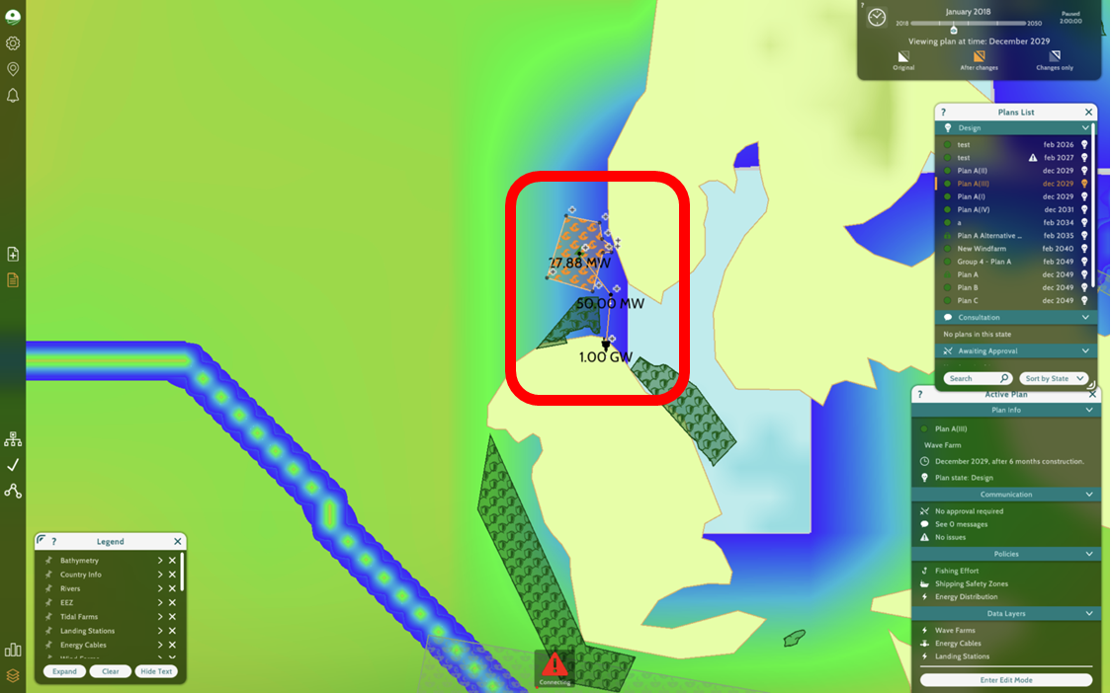

One landing station would be required at Murra, which makes construction efficient. Furthermore, this payoff is significant: Hoy Island would gain full energy independence through a predictable and renewable source. The location benefits from consistent wave activity, a factor already being utilized by test installations at EMEC in Orkney. Wave technology also has a lower profile in the water, resulting in minimal visual and ecological disturbance.

Of all the proposed strategies, Alternative 3 presents the strongest alignment with technical feasibility, environmental safety, and stakeholder consensus. It combines modern marine engineering with low ecological risk and offers a model for decentralized, resilient island energy systems.

Wave energy systems in Orkney (via EMEC) have been proven to operate reliably with minimal impact on marine biodiversity (EMEC, 2024). This precedent strengthens confidence in both public acceptance and long-term operational sustainability.

## Community Perspective on Alternative III

This section presents a detailed breakdown of Alternative 3 using the MSP Challenge simulator. Two core data layers — Activities and Ecology — were analyzed to assess the plan’s interaction with marine uses and environmental sensitivities. The goal was to ensure the selected plan supports sustainable wave energy development with minimal conflict and ecological impact.

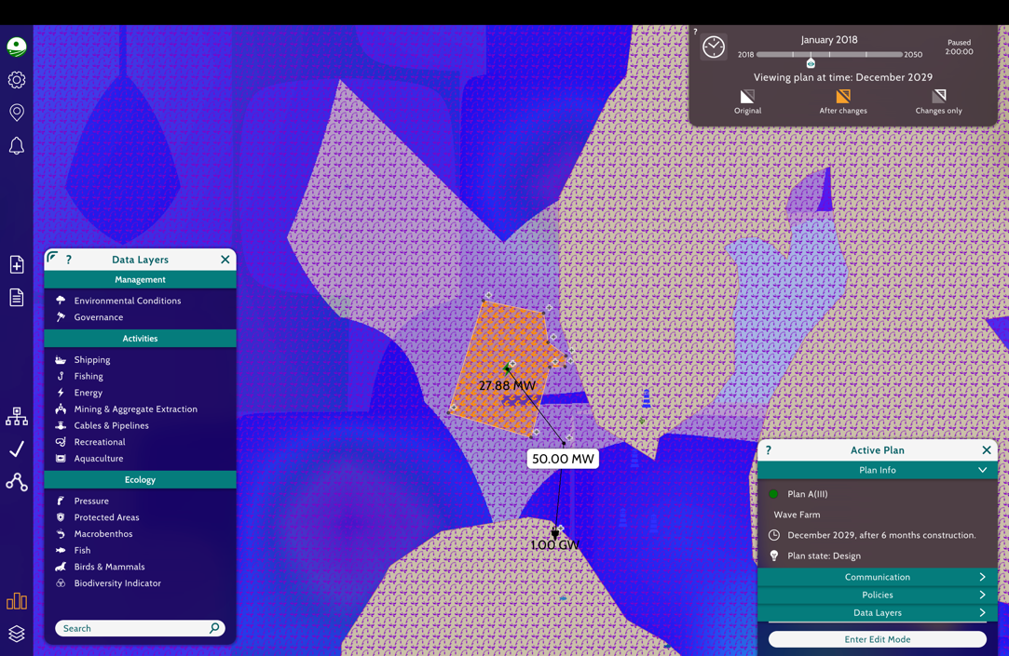

This screenshot captures the active marine use layers — including shipping, fishing, energy, recreation, and cables — overlaid on the December 2029 plan view. The selected wave farm site, producing 27.88 MW, is strategically placed in a moderately active marine corridor. The infrastructure includes a 50.00 MW cable junction, connecting the site to a 1.00 GW substation located southward, nearshore.

This routing reflects a highly considered placement strategy. The wave farm lies outside major commercial shipping routes and dense fishing grounds, significantly reducing spatial conflict likelihood. While some low-to-moderate fishing activity is present in the area, these are not considered primary or high-density zones. As a result, any temporary access restrictions during installation would be short-lived and manageable with advance notice and coordination with local users.

Moreover, the selected area does not interfere with aquaculture zones, recreational boating hubs, or aggregate extraction sites. This further supports the conclusion that Alternative 3 minimizes human-use overlap. By positioning the cable through open water zones and maintaining distance from key transport corridors, the project ensures continued access for small-scale fishers and recreational vessels post-construction.

In terms of energy design, the infrastructure shown reflects a scalable build-out—beginning with moderate output and integrating into a high-capacity grid node. This forward-compatible design enhances the project's long-term value without necessitating future spatial expansion.

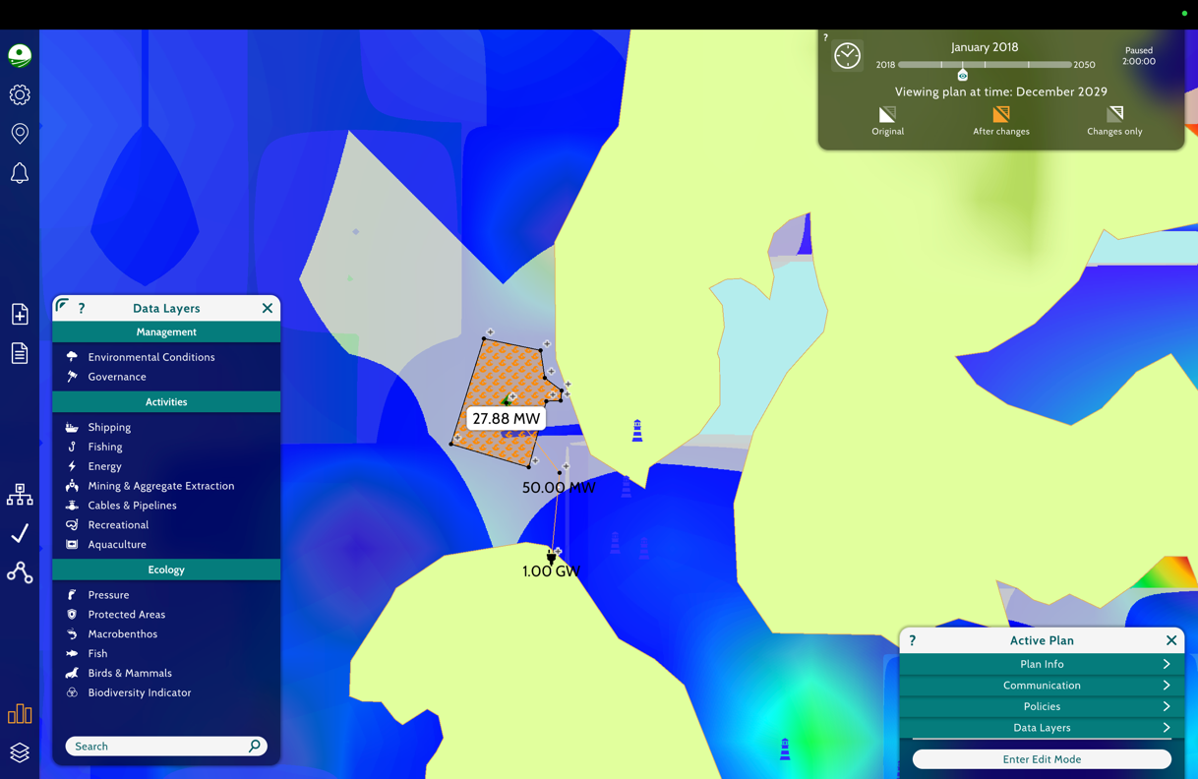

This screenshot provides a view of environmental sensitivity layers, specifically biodiversity indicators, birds and mammals, and macrofauna distribution. In this visualization, purple and pink shading indicate areas of moderate to high ecological value, while lighter zones represent fewer sensitive waters.

The wave farm and associated cable pass through regions with moderate ecological presence, particularly concerning marine mammal and seabird activity. However, the route avoids the highest-density ecological zones and does not intersect with designated marine protected areas or conservation reserves. This reflects a conscious effort to avoid highly sensitive habitats while still accessing strong wave energy potential.

Although some ecological disturbance is possible during installation, particularly through underwater noise and sediment disruption, mitigation strategies can significantly reduce these impacts. These include timing construction to avoid critical life-cycle periods (such as spawning or migration seasons), using low-noise installation technologies, and applying post-installation environmental monitoring to assess longer-term effects on local species behaviour.

The ecological trade-offs here are minor and reversible, especially compared to other proposed routes that risk intersecting conservation zones or core habitat corridors. Plan A demonstrates a well-informed balance between utilizing ocean space for sustainable energy and preserving the marine environment's biodiversity.

## Conservationist POV – Alternative III

This section evaluates the environmental and technical merits of Alternative 3, focusing on the wave energy infrastructure's footprint and sustainability outcomes. According to the MSP simulator, this plan yields the cleanest environmental profile among assessed options, as wave energy technology presents minimal disruption to marine ecosystems (as shown in the photo depicted below).

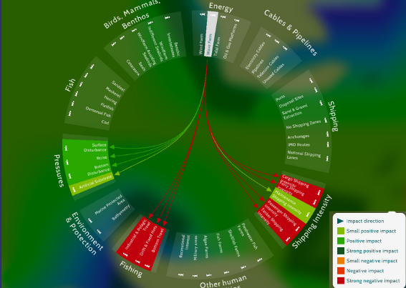

The alternative is also optimized to reduce ecological interference. By placing the infrastructure in a moderately active marine corridor away from high-density aquaculture zones and marine protected areas, the plan helps to minimize ecological disruption/damage. Notably, the proposed cable route was mapped through regions with very low densities of benthic invertebrates, sandeels, and large fish—addressing conservationist concerns about sensitive species distribution along the cable path (shown in the figure below). This strategic placement helps avoid biologically rich zones, ensuring minimal impact on the surrounding ecosystems.

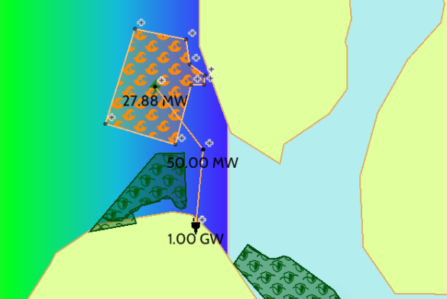

Geo-Layers Include: Fish, Macrobenthos, Protected Areas, Biodiversity Indicator

Legend: Green = Medium Density of Marine Life, Blue = Low Density of Marine Life, Dark Blue = Very Low Density of Marine Life,

Additionally, predictive ecological modeling assessed the long-term impacts of cable construction on seals, cetaceans, and overall biodiversity. Results showed low seal density in the route area, and no critical marine mammal habitats were identified along the cable corridor. These findings support the conclusion that construction will have minimal long-term ecological effects, with no major disturbances to biodiversity anticipated. Low-to-moderate recreational and fishing use in the area also ensures that temporary access restrictions during installation would be short-lived and manageable with minimal local disruption. For your additional reference, a heat map of seal density within the proposed construction area for this alternative can be seen in the figure below:

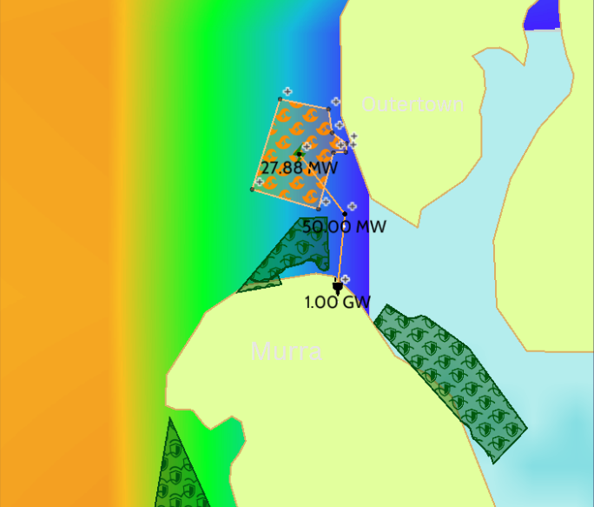

Legend: Orange = High Density of Seals, Green = Medium Density of Seals, Light Blue = Low Density of Seals, Dark Blue = Very Low Density of Seals

To reinforce its ecological benefits, this route was strategically planned to avoid all marine protected areas and high-biodiversity zones. It passes through regions marked by low biodiversity indicators, particularly areas with limited large fish presence. This approach reduces the risk of ecological disruption and makes the plan ideal for long-term marine conservation compatibility. Stakeholder interviews and simulation data further supported this route’s suitability, ensuring community alignment with ecological and operational priorities.

To maintain biodiversity protection beyond initial development, the plan incorporates a proactive monitoring system. Conservationist strategies include pre- and post-construction ecological assessments and the use of automated tools to detect unexpected shifts in marine life activity. If unforeseen impacts arise, an adaptive management model will allow for responsive interventions without delaying energy production goals.

For conservationists, Alternative 3 represents a forward-compatible, low-conflict renewable energy solution. With its efficient marine spatial planning, scalable energy output, and comprehensive ecological safeguards, Alternative 3 offers a robust framework for sustainable marine development and long-term energy autonomy.

## Recommendations

Community Recommendations:

After a thorough review of spatial data, ecological sensitivity overlays, stakeholder considerations, and infrastructure planning using the MSP Challenge Simulator, we confidently recommend moving forward with Alternative 3. This recommendation is based on clear evidence that this plan provides the most balanced approach among the alternatives analyzed — achieving energy goals while safeguarding marine access and ecological integrity.

Alternative 3 was developed through collaborative efforts with the broader planning team, including dedicated community input from key stakeholders such as Vitor and Isai, who provided critical insights into local marine use, fishing practices, and community sensitivities. Their contributions helped shape a plan that minimizes interference with existing livelihoods, maintains recreational and cultural access to coastal waters, and supports long-term ecological sustainability.

From a marine spatial planning standpoint, Alternative 3 offers a smart placement of the wave energy farm and its associated infrastructure. By avoiding major commercial shipping routes, high-intensity fishing grounds, and aquaculture zones, the plan significantly reduces the likelihood of conflict with existing marine users. Additionally, the routing of the energy cable through less congested open waters ensures that small-scale fishing and recreational activities can continue with minimal long-term disruption. These spatial decisions contribute to a project that respects both the community’s economic interests and its connection to the sea.

From an environmental perspective, the analysis of ecological layers confirms that Alternative 3 avoids the most sensitive marine habitats, including designated protected areas and high-density biodiversity zones. While the infrastructure does pass through zones of moderate ecological sensitivity, the trade-offs are minimal and manageable. Mitigation strategies — such as seasonal construction timing, low-impact installation methods, and ecological monitoring protocols — can ensure that impacts remain temporary and reversible. The potential for biodiversity recovery post-installation is high, particularly given the project’s avoidance of core habitats and critical migration paths.

Furthermore, Alternative 3 aligns well with regional energy transition goals by contributing up to 1.00 GW of clean wave energy to the local grid. The design is inherently scalable, allowing the region to meet future energy demand without extensive additional marine development. This positions the project as a long-term solution for decarbonization and energy resilience, supporting both local and national climate objectives.

In terms of community benefit, this plan has the potential to create local employment during both construction and operation phases, contribute to regional economic diversification, and improve energy reliability for island communities that have historically faced supply challenges. These benefits are measurable and should be accompanied by performance indicators such as local job creation data, energy delivery metrics, and community satisfaction surveys.

Given the findings outlined in this report and the consensus among technical and community stakeholders, we recommend the implementation of Alternate 3 with the following safeguards and strategic actions:

* Ensure seasonal construction scheduling to avoid sensitive ecological and fishing periods.
* Maintain ongoing engagement with community members, fishers, and local authorities to proactively coordinate activities and address concerns.
* Deploy low-noise, low-impact technologies during cable and wave infrastructure installation.
* Establish a post-construction ecological monitoring program to assess and adapt to unforeseen environmental effects.
* Develop a community benefit framework, including hiring targets, reinvestment opportunities, and transparent reporting on energy and economic impacts.

By proceeding with these measures, Alternate 3 will serve as a model for responsible, sustainable marine energy development that demonstrates how environmental stewardship, community priorities, and renewable innovation can coexist successfully.

## Conservationist Recommendations:

To safeguard biodiversity and ensure the responsible development of wave energy infrastructure under this plan, the following stakeholder-informed recommendations are proposed:

First, pre- and post-construction biodiversity surveys should be implemented to establish a clear ecological baseline and monitor changes over time. These surveys will help assess the presence and activity of key marine species in and around the project area. By identifying early signs of ecological disturbance, developers can apply mitigation strategies promptly—such as halting construction during sensitive periods or adjusting cable routes if new marine habitats are detected.

Second, the project should deploy automated monitoring technologies, such as sonar systems and acoustic sensors, to gather continuous environmental data throughout construction and operation phases. These tools provide a non-invasive way to observe marine life behavior, detect anomalies, and record activity patterns in real time. This constant stream of data enables project managers and conservation teams to make informed, timely decisions that reduce harm to the marine ecosystem.

Third, the plan must include a robust adaptive ecological management framework. This involves creating flexible operational guidelines that can respond to ecological feedback. Should unexpected impacts arise—such as unanticipated species migration or temporary declines in biodiversity—project teams must be prepared to modify timelines, relocate certain components, or introduce enhanced protective measures. Adaptive management ensures resilience in the face of uncertainty, aligning long-term project success with environmental responsibility.

This plan reinforces a commitment to sustainable marine energy development while prioritizing long-term biodiversity protection, transparent environmental stewardship, and a cooperative relationship with marine stakeholders.

## Developers Recommendations:

As the Developers Group, we fully support and endorse Alternative 3 as the most balanced and future-ready solution for powering Hoy Island. After extensive collaboration with both the Community and Conservationists groups, and a thorough review of technical, ecological, and spatial planning data, we are confident that this plan achieves the necessary energy goals while respecting both the environment and the livelihoods of those who depend on the sea.

From a technical standpoint, Alternative 3 features a 27.88 MW wave farm located near Outer town, connected to a 1.00 GW landing station at Murra via a 4.98 km subsea cable. This infrastructure is both efficient and streamlined, minimizing energy loss and complexity. The placement avoids major ecological and navigational conflict zones, ensuring smooth installation and operation. The short cable distance, combined with a direct route and single landing station, simplifies maintenance and long-term infrastructure management.

In alignment with the Community Group’s feedback, we recognize the importance of avoiding disruption to traditional fishing grounds, cultural marine access, and recreational spaces. This plan respects these priorities by placing infrastructure away from high-use community areas and allowing continued small-scale marine activities. The input from local stakeholders like Vitor and Isai was instrumental in shaping a solution that fits the island’s social and economic fabric.

We also acknowledge and appreciate the Conservationists Group’s insights, particularly regarding ecological sensitivity. Their recommendation for seasonal construction, ecological monitoring, and the use of low-impact installation techniques aligns with our commitment to responsible development. We fully support these safeguards and will integrate them into our technical planning and execution phases.

Lastly, Alternative 3 provides a strong foundation for energy independence and long-term sustainability. Its scalability and clean energy output directly contribute to Scotland’s renewable energy goals and offer economic opportunities for local communities.

## Conclusion

The Electrifying Hoy Island project showcases the strength of multi-stakeholder marine spatial planning in solving complex real-world energy challenges. Through extensive simulation, environmental analysis, and community consultation, Alternative 3 emerged as the most balanced, sustainable, and forward-compatible solution for delivering reliable electricity to Brims on Hoy Island. Its offshore wave energy infrastructure offers not only technical feasibility and minimal environmental impact but also community acceptance and alignment with regional energy goals.

Alternative 3 succeeds by avoiding Marine Protected Areas, minimizing disruption to marine biodiversity, and respecting key fishing and shipping activities. The plan reflects deep consideration of ecological sensitivities, including low marine mammal density, limited benthic and sand eel presence, and clear exclusion from high-risk zones. These findings were corroborated by conservationists, developers, and community groups alike, whose combined input shaped the project's final design.

From a conservationist perspective, the integration of pre- and post-construction biodiversity surveys, real-time monitoring tools, and adaptive ecological management ensures long-term protection of Hoy’s marine ecosystem. For the community, the plan supports energy independence, job creation, and economic resilience, while safeguarding traditional marine uses. Technically, the short cable distance, single landing station, and proven wave energy performance position the infrastructure for long-term success with minimal operational complexity.

In sum, this project serves as a model for how inclusive, data-driven marine planning can harmonize renewable energy ambitions with ecological and community values. Alternative 3 offers a blueprint for future offshore energy initiatives—one that proves sustainable development is not only possible, but also powerful when built through shared understanding and cooperation.

## References

*Marine Scotland - National Marine Plan Interactive*. (n.d.). <https://marinescotland.atkinsgeospatial.com/nmpi/default.aspx?layers=846>

*SiteLink - Map Search*. (n.d.). <https://sitelink.nature.scot/map>

*Marine Government Scotland* (2013)*. Completed projects .* <https://marine.gov.scot/?q=themes/completed-projects>

*EMEC.* (2017). *European Marine Energy Centre.*  <https://www.emec.org.uk/facilities/>

SIMEC Atlantis Energy. (2025, March 28). *MEYGEN - SAE Renewables*. SAE Renewables. <https://saerenewables.com/tidal-stream/meygen/>

*Beatricewind*. (n.d.). Beatricewind. <https://www.beatricewind.com/>

*Offshore renewable energy installations: impact on shipping*. (2024, January 16). GOV.UK. <https://www.gov.uk/guidance/offshore-renewable-energy-installations-impact-on-shipping>

MSP Challenge. (2024). Marine Spatial Planning Simulator – Version 3.0 [Computer software]. Wageningen University & Research; North Sea Foundation. <https://www.mspchallenge.info/>

Orkney Islands Council. (2020). Sustainable energy strategy for Orkney. <https://www.orkney.gov.uk/>

Schweizer, P. J., Renn, O., & Klinke, A. (2018). Marine spatial planning and risk governance. Marine Policy, 94, 10–19. <https://doi.org/10.1016/j.marpol.2018.04.017>

## Appendices

All the background work from the prepared steps goes into appendices.

### Developer Group Report Hoy Island Energy Access Project

Hoy Island, particularly the town of Brims, currently lacks any electrical infrastructure. The absence of power supply limits economic development, quality of life, and local sustainability. The initial proposed solution (Actual Plan) was a direct undersea cable from Gills Bay to Brims. While seemingly simple, this plan conflicted with multiple marine user zones and required reassessment.

The central question became: **How can we bring clean, reliable electricity to Hoy Island in a way that minimizes conflict with marine protected areas, fishing zones, and shipping corridors, while remaining cost effective and technically viable?**

With considering the problem statement the developers have come up with some alternatives of the Actual plan. All the plans are explained in detail below:

#### Actual Plan: Direct Undersea Cable from Gills Bay to Brims (Hoy Island)

Plan proposed laying a submarine electrical cable from Gills Bay on the northern coast of mainland Scotland directly to Brims, a coastal township on Hoy Island in the Orkney archipelago. The total undersea distance for this route would span approximately 17.66 kilometers across the Pentland Firth, a notorious stretch of turbulent water between the Scottish mainland and Orkney. The cable would connect to an existing landing station at Gills Bay and require the construction of a new one at Brims. The route, however, raises substantial concerns.

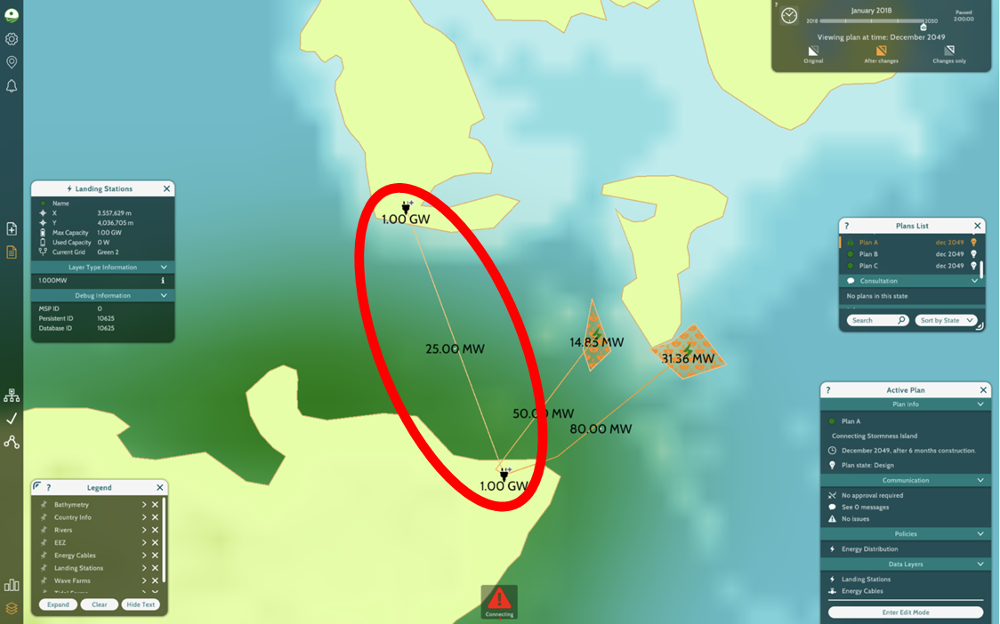

Geographically, this area intersects with several zones of high marine sensitivity. The proposed cable path runs through a designated Marine Protected Area (MPA), home to vulnerable marine ecosystems and species. Any development within these waters would likely face stringent regulatory resistance. Moreover, the route overlaps with active commercial shipping lanes used by ferries and cargo vessels navigating between the Atlantic and the North Sea. In addition, the area is heavily utilized by fishing fleets practicing bottom trawling, posing a risk not only to the cable itself but to the fishing industry’s economic well being.

From an engineering perspective, the seabed along this route is a combination of hard and uncategorized sediment, adding complexity to cable trenching and anchoring. The long cable length increases energy transmission losses and introduces greater maintenance challenges. While Actual Plan may seem simple in its directness, the combined environmental, logistical, and stakeholder conflicts make it unfeasible for real world implementation.

**Community Perspective**

Hoy is one of the larger islands in Orkney, with a range of activities taking place both on land and in the surrounding waters. The population is modest, but the community is deeply connected to the sea. Fishing, ferry transport, and coastal tourism are central to life on the island. The seabed south of the island and near the entrance to Scapa Flow includes key fishing grounds. Scallop beds near South Walls and creeling zones along the coast support local livelihoods, especially for fishers who rely on them year-round. Lyness and Longhope harbours serve as the main points of access. Lyness is the primary ferry terminal, and Longhope supports fishing vessels and the RNLI lifeboat. Any nearshore construction—including cable landfall—would need to be carefully timed and managed to avoid interrupting ferry schedules or emergency services.

Cable construction must be planned with full understanding of how much islanders rely on the sea. Local fisheries provide income for many residents, and any disruption to fishing areas, even temporary, can have consequences. Ferry services are a lifeline, connecting Hoy to the mainland. Their schedules must not be affected by cable-laying vessels or safety zones. Emergency response is also a key concern—Longhope hosts an RNLI lifeboat station, and its access to the sea must be always maintained. The waters around Hoy are also used by charities and tour operators offering services to residents and visitors alike. The RNLI, for instance, plays a role in safety, while other groups provide recreational and wellbeing activities using the marine environment.

**What We Considered**

To assess Plan A from a community perspective, we focused on five central questions:

1. What marine activities do local communities on Hoy depend on along the cable route, and how might construction interfere with those activities?
2. How might construction or presence of the cable affect marine conditions that support livelihoods, like fish availability or safe access to coastal waters?
3. What are the trade-offs for communities on Hoy if Plan A moves forward as designed—in terms of access, safety, and day-to-day activities?
4. Where are areas of high marine use or value to communities on Hoy that should be treated with caution during cable installation?
5. What long-term benefits does Plan “A” offer to communities on Hoy Island (e.g., improved energy access or economic opportunities), and how can those be measured or ensured?

**Conservationist Perspective**

As a group of conservationists, Hoy Island in Orkney, Scotland is truly a special place. It's one of the wildest and most ecologically diverse islands in the region, with dramatic cliffs, cast moorlands, and rich marine life. The island's remote nature helps them preserve its habitats, from heather-covered hills to rare woodlands like Berriedale, one of Orkney's only natural forests.

Hoy is especially important for birdlife. It's an RSPB nature reserve and home to red throated divers, puffins, skuas, and even white –tailed sea eagles, which we reintroduced and now nesting again. These species depend on the islands' quiet, undisturbed areas for breeding and feeding.

The waters around Hoy are just as vital. Kelp forest, reefs, and seabed's support sand eels, cod, lobsters, and wide range of marine life. Seals are common here, and sightings of orcas and porpoises remind us how rich this ecosystem is. These marine areas are protected under various conservation laws, including Marine Protected Areas and Special Areas of Conservation. (Specially Protected Areas)

Preserving Hoy means protecting not just the land, but also the delicate balance in the surrounding sea. Development or infrastructure projects here must be carefully planned to avoid disrupting these habitats. For conservationists like our group, Hoy is more than just beautiful- It is a place worth protecting for future generations of people and wildlife alike.

**What We Considered:**

Since the environmentalists did not agree with the actual plan, we and the community members have been involved in coming up with an alternative to bring Hoy Island clean and renewable energy.

In order to assess the plans proposed by the developers, we shall be focusing on the following key business questions to measure if they are safe for the marine ecology while ensuring we protect the ocean and the inhabitants. The questions are:

1. What is the current density of benthic invertebrates, sand eels, and large fish along each cable route?
2. What are the long-term ecological impacts of cable construction on seals, cetaceans, and biodiversity?
3. Which mitigation strategy should be prioritized to reduce ecological damage?
4. Where can able routes be placed to fully avoid protected areas and high-biodiversity zones?
5. How can we ensure biodiversity protection through effective monitoring systems during and after the project?

#### Alternative 1: Tidal Farm Installation Near Brims (Hoy Island)

Alternative 1 proposes a local renewable generation model centered around a tidal energy farm placed offshore from Brims on Hoy Island. The location benefits from the powerful tidal currents of the Pentland Firth, making it an ideal candidate for harnessing tidal energy. A 50 MW tidal farm would be connected to a new landing station at Brims via a short 2.09 km submarine cable.

This plan’s most notable strength is its simplicity and efficiency. A short cable run minimizes energy loss, while the infrastructure required is minimal only one farm and one landing station. The plan ensures complete energy independence for Hoy Island, aligning with sustainability goals and community resilience.

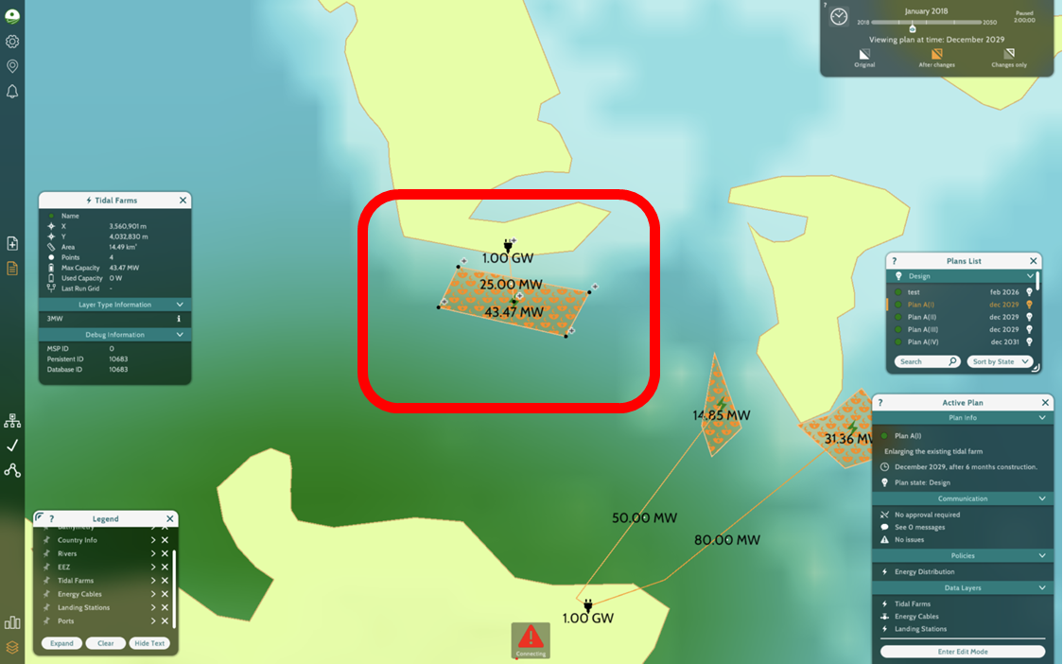

However, while the cable avoids MPAs and shipping routes, the proposed tidal farm is situated near an active bottom trawling zone. This may cause tension with local fishers, as energy infrastructure could reduce access to fishing grounds. Although the seabed is uncategorized, preliminary surveys would be necessary to assess any technical installation risks.

This model mirrors success stories like the MeyGen project in Caithness and the self-sufficient Isle of Eigg in the Inner Hebrides. If fishing concerns can be mitigated through stakeholder engagement and compromise, this alternative offers a clean and robust solution.

**Community Perspective on Alternative 1**

This section provides a detailed assessment of **Alternative 1 (Plan A[I])**, focusing on its spatial configuration, proximity to community activities, and environmental considerations. The analysis draws from the MSP Challenge simulator’s visual outputs, particularly tidal farm placement, cable routing, and high-use community zones around Hoy Island and Orkney. The objective is to evaluate the compatibility of the proposed infrastructure with local marine livelihoods, transportation patterns, and long-term energy strategy.

Marine Use & Infrastructure Assessment:

The first screenshot captures the tidal farm configuration planned for installation just off Hoy Island, with connectivity to a 1.00 GW substation via submarine cable. The expanded tidal farm's total maximum capacity is **43.47 MW**, of which **25.00 MW** is currently planned for use. The layout leverages an area of **14.87 km²**, ensuring ample space for scalable future development while remaining compact enough to limit marine user displacement.

The siting of the tidal farm reflects thoughtful marine spatial planning. It occupies a region with reliable tidal flow but **avoids areas heavily trafficked by shipping and ferries**. This minimizes the risk of navigation conflict and supports smooth installation and long-term operation. Additionally, the route of the connecting cable is straightforward and linear, reducing technical complexity and seabed disturbance during deployment.

Crucially, the tidal farm’s placement ensures no overlap with known aquaculture operations or mining zones, and the simulator does not register any flagged issues at the design phase. This strategic avoidance of conflict zones positions Alternative 1 as a viable marine energy solution, albeit with a few social trade-offs that require careful mitigation.

Community Use and Potential Impacts:

The second screenshot offers a layered community analysis by categorizing potential impacts into **descriptive, predictive**, and **stakeholder trade-off** perspectives. Communities surrounding Hoy Island rely on these waters for **inshore fishing**, **recreation**, and **marine tourism**, all of which may face short-term disruption during construction.

The presence of **cable-laying vessels**, **marker buoys**, and active installation work may temporarily alter marine currents and restrict access to key fishing zones. This could affect **shellfish availability** or compel fishers to move to less optimal areas, impacting their yield and income. However, these disturbances are short-lived and can be minimized with early communication and temporary marine routing notices.

Stakeholder trade-offs center on **temporary access loss**, **increased marine noise**, and brief interference with recreational routes. In return, the community gains greater **energy reliability**, especially during winter peaks when Orkney’s energy demand rises. Overall, these impacts are not permanent and can be resolved through **clear community engagement, real-time notices**, and strategic construction timing.

Ecological and Location Sensitivity:

This final slide provides insights into **high-value marine zones** intersecting with the project area. Notably, the cable route passes near **traditional fishing grounds**, **ferry corridors**, **wreck sites**, and an **aquaculture facility at Pegal Bay**. These areas have both economic and cultural significance and should be treated with extra caution during planning and installation phases.

The placement of the cable connection at the **Finstown Substation**, as shown on the Orkney location map, supports regional grid integration and demonstrates a larger system design that accommodates both technical scalability and spatial awareness.

The long-term community impact of Plan A(I) is projected to be substantial. Simulator data estimates a direct contribution of **£371 million to the Orkney economy**, alongside improved energy access, economic diversification, and reduced reliance on fossil fuels. These benefits align with broader decarbonization goals and affirm the tidal farm’s role in Orkney’s sustainable energy future.

Conclusion:

Plan A(I) presents a **well-considered marine energy project** with clear long-term value and a relatively low ecological footprint. The tidal farm is carefully located to avoid dense human-use zones, while the cable routing is straightforward and free of major logistical constraints. Community-level trade-offs — including temporary fishing and tourism interference — are present, but manageable through **seasonal installation timing**, **local coordination**, and **post-construction recovery**.

Environmental risks are minor and do not intersect with protected zones or high-sensitivity ecological corridors. By ensuring open dialogue with local marine stakeholders and implementing safeguards during construction, this plan can deliver sustained benefits to Hoy Island and Orkney communities. With support from the broader planning team and community partners, Plan A(I) can move forward as a **sustainable and regionally appropriate solution** for tidal energy expansion.

**Conservationist Perspective on Alternative 1**

From a conservationist point of view, Plan A raises some key ecological concerns. While it aligns with sustainability goals by promoting renewable energy, its location and potential impacts present serious risks to marine biodiversity—risks that cannot be overlooked.

The proposed tidal farm borders the Hoy Special Protected Area (formerly part of Natura 2000 in EU), and the surrounding waters support medium-density populations of benthic invertebrates, sand eels, and large fish. These species are foundational to the food web and contribute to the ecological balance of the region.

Of particular concern is the proposed cable route, which passes through a high-density seal area, with very high expected impacts due to underwater noise and electromagnetic radiation. Construction would also disturb sand eel habitats and affect cetaceans through sediment disruption and acoustic interference. These impacts go beyond isolated incidents—they have long-term implications for species health, recovery, and migration behavior.

Though the developers note that the plan avoids MPAs and shipping lanes, it comes dangerously close to zones of ecological significance, especially near seal haul-outs and sandeel-rich habitats. Without careful route adjustment and proper mitigation, Plan A could result in lasting damage to biodiversity and ecosystem services.

We believe more work is needed to make this plan ecologically responsible. At a minimthe um, we recommend:

* Delaying construction during seal pupping and breeding seasons
* Rerouting portions of the cable away from sensitive seal and sandeel areas
* Implementing real-time visual and acoustic monitoring for seals and cetaceans
* Conducting thorough biodiversity assessments before and after installation

Although Plan A has potential, we do not support it in its current form. The plan's environmental costs outweigh its energy benefits unless concrete mitigation strategies are adopted. (See Appendix B for supporting ecological data and maps.)

#### Alternative 2: Using Existing Mainland Tidal Farms via Island Hopping Cable Route

Alternative 2 proposes leveraging existing tidal generation assets on the Scottish mainland, specifically two operational farms generating 14.85 MW and 31.36 MW, respectively. Instead of a direct cable to Hoy, this plan routes energy via several island nodes: from the mainland to Burwick on South Ronaldsay, then to Herston on South Walls, and finally to Brims on Hoy Island. The total undersea cable length is 7.18 km, but the project also involves multiple overland connections and at least four undersea crossings.

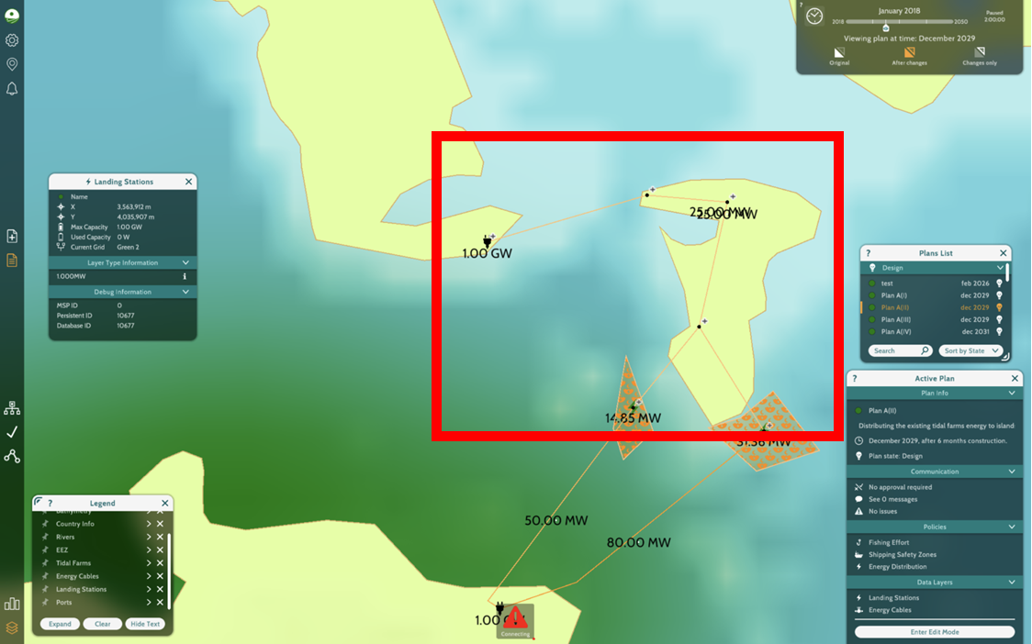

This approach minimizes new infrastructure by capitalizing on existing farms, which could reduce immediate capital costs. It also avoids MPAs and shipping routes, providing an ecologically safer option than Actual Plan. However, the cable’s passage through moderate intensity fishing areas could still disrupt marine livelihoods. The seabed along this route is characterized by mixed sediment, which complicates anchoring and cable protection.

Logistically, this is the most complex alternative. The segmented structure increases the chances of mechanical failure and makes maintenance more labor intensive. Moreover, the energy supplied to Hoy would still be dependent on the mainland grid and infrastructure, reducing the island’s autonomy and resilience.

Though environmentally moderate, the high operational complexity and partial energy dependency make this plan less favorable from a long term development standpoint.

Community perspective on Alternative 2

Active fishing grounds, significant shipping and ferry routes, and coastal regions with recreational, cultural, and economic significance are all traversed by the proposed cable line. These areas are central to community life and are neither marginal nor low use. Daily access to the sea would be disrupted by construction, which would also have an impact on commercial and traditional fishing and increase vessel traffic in already crowded marine routes. The cable may result in long-term restrictions on local boaters' and fishermen's access, safety, and freedom of movement even after construction is over.

These are not merely technological problems; they pose a direct risk to safety, customs, and livelihoods. The interruptions are more than just short-term annoyances. For coastal communities who depend on these waters on a daily basis, they have tangible, long-lasting effects.

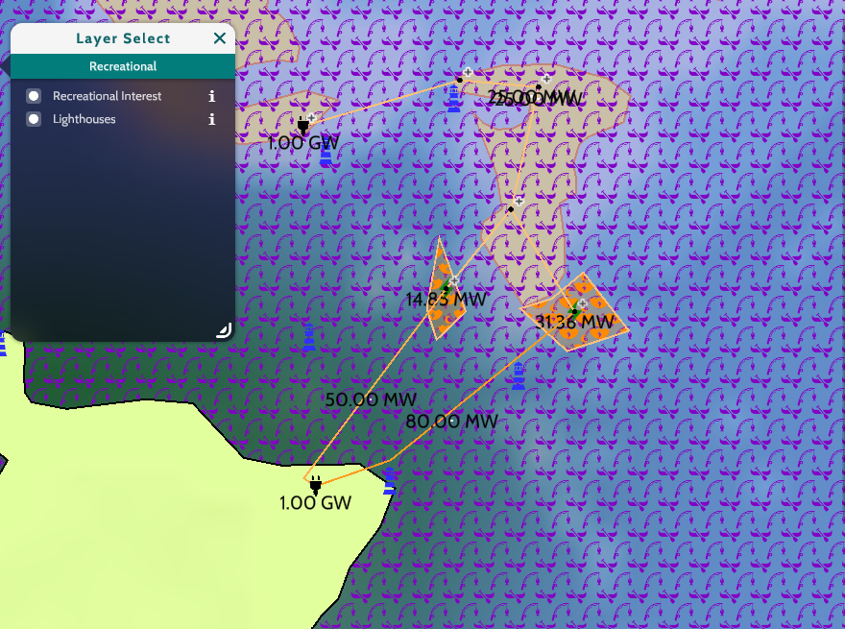

In the image above we see that the cable routes pass through zones marked for recreational interest, particularly near the mainland. These are likely used for fishing, boating, and leisure activities that are important to community life and local tourism.

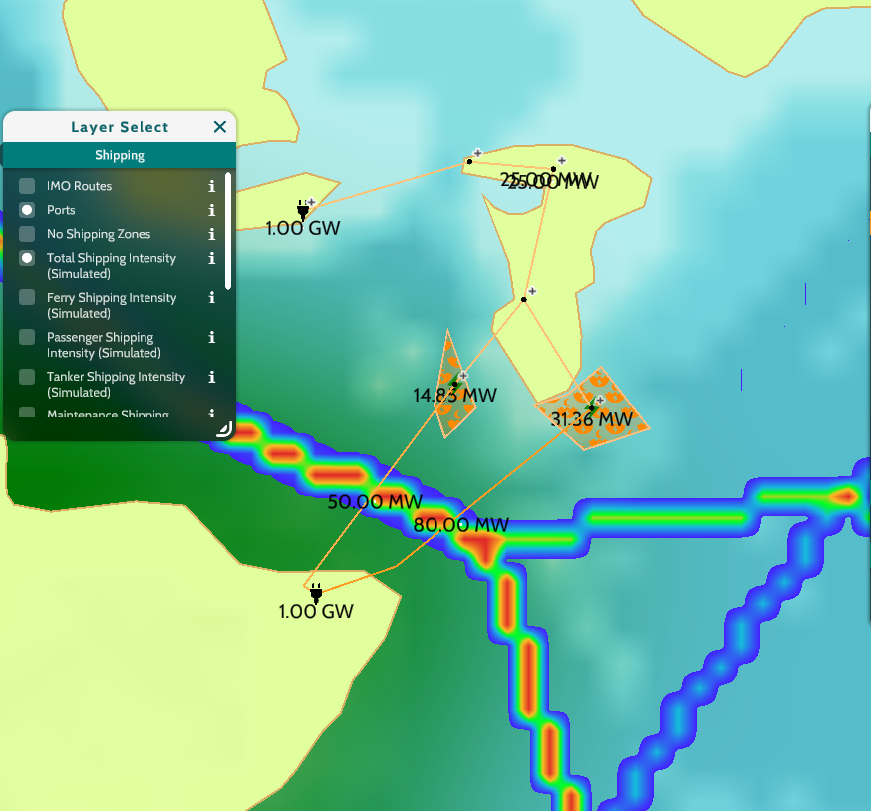In the Shipping Layer above, we observe that the same cable routes intersect with high-intensity shipping corridors, shown by the red and yellow heat zones. These include Ferry routes used by passengers, Cargo and tanker routes critical to supply chains, and Coastal access points near harbours and ports.

In addition, we analyze Alternative 2 plan through our 5 questions:

1. Descriptive Analysis

What marine activities do local communities depend on along the cable route, and how might construction interfere with those activities?

The cable route intersects areas of high marine use, particularly zones important to local communities for recreation, tourism, and fishing. These areas include coastal waters that facilitate recreational boating and fishing as well as small-scale and subsistence fishing. The route also crosses existing shipping routes, such as those used by cargo ships, tankers, and passenger ferries. Construction projects in these locations have the potential to seriously disrupt regular marine operations. Temporary exclusion zones, restricted access to traditional fishing grounds, and restrictions on boat movement are a few examples of this interference, which can interfere with recreational activities and livelihoods.

1. Predictive Analysis

How might construction or the presence of the cable affect marine conditions that support livelihoods, like fish availability or safe access to coastal waters?

The cable laying and construction could disturb delicate maritime ecosystems, particularly seabed’s, which are vital to many marine species. Seabed disturbance can have a detrimental effect on breeding and feeding grounds, change fish behavior, or decrease availability in known fishing regions. Additionally, smaller community-operated boats may have less safe access due to increased marine vessel traffic brought on by development, making them more vulnerable to collision hazards or wake damage. These effects could limit local populations' capacity to safely navigate their coastal waterways and lower fishing productivity.

1. Prescriptive Evaluation:

What are the trade-offs for communities if this Plan moves forward as designed — in terms of access, safety, and day-to-day activities?

If the current plan proceeds without modification, local communities face several trade-offs:

* restricted access to the nearshore and coastal regions they depend on for travel and fishing.
* increased dangers to safety, especially for non-commercial or small-scale ships passing close to building sites.
* disturbance of economically and culturally significant activities, such as fishing, leisure, and coastal gatherings.

Although the project encourages the growth of renewable energy, it may come at the expense of lowering daily security and community autonomy in marine areas that locals have historically used and treasured.

1. Location Analytics

Where are areas of high marine use or value to communities that should be treated with caution during cable installation?

Several locations along or close to the cable route have been identified as having significant community value based on geographic data layers:

* shorelines, which offer essential access for leisure activities like fishing.
* Ferry routes are crucial for transportation on the mainland and between islands.
* Local fishermen regularly use these traditional fishing areas to supplement their income and ensure their food security.
* Aquaculture facilities and wreck sites, like the one in Pegal Bay, provide local economy and ecological diversity.

When installing cables in these places, more care should be taken, including careful planning, potential rerouting, and close communication with local stakeholders.

5. Impact on Stakeholders

What long-term benefits does Plan A offer to nearby communities, and how can those be measured or ensured?

Significant long-term advantages for nearby towns could result from alternative 2, including:

* enhanced dependability and accessibility of energy for coastal areas.
* creation of jobs, especially during the phases of development and upkeep.
* cleaner energy infrastructure, supporting local sustainability and climate adaptation objectives.
* the possibility of drawing in more funding for local infrastructure.

However, a number of steps should be taken to guarantee that these advantages are significant and fair. These consist of:

1. giving local employment and training for positions involving cable construction and maintenance a priority.
2. carrying out frequent impact analyses that incorporate socioeconomic metrics related to the welfare of the community.
3. putting in place systems for continuing community involvement, including co-governance bodies or advisory committees.

Incorporating accountability and equality into project execution can improve long-term support and better connect the strategy with community interests.

We believe that while Alternative 2 may be technically feasible, it is not the most community-conscious or balanced approach. Other routing options could meet the project’s energy goals with significantly less impact on local people. Based on our analysis, we do not support Alternative 2 in its current form.

Conservationists' perspective on Alternative 2: Burwick → Herston → Brims Cable Route

Alternative 2 proposes to cable the energy from Burwick through Herston to Brims, tracking existing infrastructure and avoiding designated marine protected areas. However, from a conservationist perspective, the route has a number of ecological concerns extrapolated from the information we have reviewed. The site has a moderate density of benthic invertebrates, a high density of sand eels, and a moderate density of big fish. This means that the waters and seabed within the region are biologically highly active and represent a key input to local food webs.

The long-term cumulative construction impacts can have significant implications for marine mammals like seals and cetaceans. The waters along the route have a very high seal density, which may use haul-out sites or breeding grounds near the area. The construction process, including cable laying and shipping traffic, could disrupt their natural behavior, especially if conducted during sensitive periods. Cetaceans, such as minke whales or porpoises, are also at risk. They are also EMF- and underwater noise-sensitive, caused by the process of cable installation and its subsequent operation. This disturbance, in the long term, has the potential to induce changes in movement patterns, foraging behavior, and even reproductive success. These potential impacts, coupled with the moderate to high biodiversity of the area, render this route a sensitive handling requirement.

To reduce environmental harm, the most important measure is meticulous timing of the construction to avoid the periods of the year when sensitive species are most active, for example, seal pupping or fish spawning seasons. Additionally, the cable should be buried deep enough to lessen EMF exposure and protect sea life. Utilizing quieter installation methods where possible will also lower underwater noise. Lastly, establishing buffer zones around significant habitats and putting trained marine mammal observers on the construction site would allow crews to stop or alter work when animals are nearby.

Although this route bypasses officially protected zones, it continues to coincide with areas of high biodiversity. Minimal realignment of the cable route, for instance, moving it further from seal-dense areas—would minimize the effect without completely dropping the route. Taking established corridors such as ferry lanes could also prevent the disturbance of pristine seabeds and habitats.

To ensure that the marine environment is protected during and after the project, there must be strong ecological monitoring. This means having baseline surveys before construction, real-time monitoring of marine mammals during the project, and follow-up studies to see how the environment is recovering. EMFs and temperature along the route of the cable will also be monitored to see if there are any unexpected effects. It is also important to publish this information publicly, so that in case of problems, the project team and stakeholders can adapt and respond on time.

In conclusion, while Alternative 2 is pragmatically advantageous, it carries a medium ecological risk, particularly to sand eels and seals. With strict timing, meticulous planning, and strong monitoring in place, it may be managed, but it nevertheless presents more risk than other alternatives like Alternative 3 that pass through less ecologically sensitive areas.

#### Analysis of 5 Key Developer Questions

**Question 1: Which alternative route or renewable energy configuration causes the least disruption to Marine Protected Areas (MPAs), fishing activity, and shipping routes between the mainland and Hoy Island?**

Among all proposed configurations, **Alternative 3** stands out as the option causing the least disruption to environmentally sensitive areas and existing marine activities. This plan proposes a wave energy farm positioned offshore near Outertown, with an undersea cable routed to Murra and then connected overland to Brims on Hoy Island. The key strength of this option lies in its geographic placement it avoids intersecting any designated **Marine Protected Areas (MPAs)**, which are critical to maintaining the health of marine biodiversity and are subject to strict regulatory controls. By steering clear of these zones, Alternative 3 reduces the likelihood of triggering complex environmental assessments or public opposition rooted in conservation concerns.

In terms of **fishing activity**, this alternative is particularly favorable. The undersea cable and farm placement avoid both **bottom trawling areas** and **shellfish collection zones**, which are vital to the local fishing economy. By not overlapping with any high density or traditional fishing areas, the plan minimizes disruption to livelihoods and avoids the risk of conflict with local fishers. This stands in contrast to Actual Plan and Alternative 1, both of which pass through or near bottom trawling zones, and Alternative 2, which intersects moderate density fishing routes around South Ronaldsway and South Walls.

Furthermore, **shipping lane conflicts** are entirely avoided in Alternative 3. The cable route and energy generation site are well outside of high traffic maritime corridors that connect the mainland to Orkney and beyond. Actual Plan, by contrast, crosses an active commercial shipping channel, posing navigational risks and requiring expensive mitigation measures.

In summary, Alternative 3 achieves a high level of ecological harmony and operational safety, making it the least disruptive option among all proposals.

**Question 2: Which plan offers the most efficient energy transmission with minimal loss over distance, considering the total capacity generated versus what reaches Hoy Island?**

When analyzing energy transmission efficiency, two primary factors come into play: the **distance the energy must travel** and the **capacity of the transmission cable**. Shorter cable distances generally result in less transmission loss, especially for AC (Alternating Current) systems, which are commonly used for local and regional connections. High-capacity cables are also better at reducing voltage drop and energy loss over distance.

**Alternative 1** offers the most efficient energy transmission from a purely technical standpoint. It features a **very short 2.09 km cable** transmitting power from a 50 MW tidal farm directly to Brims. Given this minimal distance, energy loss is almost negligible. This setup is ideal for ensuring that nearly 100% of the generated energy reaches its destination, maximizing system efficiency and reducing operational costs.

**Alternative 3** also performs very well in terms of efficiency. The wave energy generated offshore near Outer town is transmitted to Murra and then to Brims via a 4.98 km underwater cable. Although the distance is slightly longer than in Alt 1, it still falls within optimal parameters for minimal loss, especially when using modern subsea cable technology. The key advantage in Alt 3 is that the route does not require any additional conversions or long detours, preserving energy integrity.

In comparison, **Actual Plan** suffers from the longest cable length 17.66 km across challenging underwater terrain. Not only does this increase the chance of energy loss during transmission, but it also raises maintenance and installation costs significantly. **Alternative 2**, which utilizes existing mainland tidal farms and island-hopping cable routes, involves multiple undersea and overland connections. Each connection adds potential for conversion loss, synchronization challenges, and vulnerability to fault conditions.

In conclusion, **Alternative 1** is technically the most efficient in energy delivery due to its short cable and high-capacity design. However, **Alternative 3** offers a nearly comparable level of efficiency while providing broader environmental and stakeholder compatibility, making it the more balanced choice overall.

**Question 3: Which plan requires the least technically complex infrastructure in terms of seabed cabling, landing stations, and energy routing through multiple islands?**

From an infrastructure standpoint, **Alternative 1** is clearly the least technically complex among all options. This plan requires the development of a single tidal farm, one landing station on Hoy Island, and a very short undersea cable. The lack of multiple cable crossings, intermediary infrastructure, or overland routing minimizes engineering challenges. This simplicity can significantly reduce construction time, minimize failure points, and streamline maintenance over the life of the system.

However, while technically simple, Alternative 1 has some potential ecological and stakeholder challenges due to its proximity to fishing zones. Nevertheless, in terms of cabling and logistics, it is the most straightforward to deploy.

**Alternative 3**, while slightly more complex, remains very manageable in modern marine engineering terms. It involves building a wave farm offshore from Outertown and using a 4.98 km submarine cable to connect to a landing station at Murra, followed by an overland connection to Brims. While two landing stations are required, the route is linear and avoids any need for island hopping or routing through multiple jurisdictions. The seabed in the proposed area is primarily hard substrate, which can be challenging for anchoring but is well understood in wave energy project design.

**Alternative 2** is the most complex configuration. It requires multiple underwater and overland cables to route power through South Ronaldsay and South Walls before reaching Hoy. Each crossing introduces additional permitting, engineering, and maintenance burdens. The need to synchronize energy from multiple existing tidal farms further complicates the system and introduces points of failure.

**Actual Plan** involves one very long cable with difficult seabed conditions and requires careful routing to avoid high risk zones, making it moderately complex in terms of engineering, though it does not involve island hopping.

Ultimately, **Alternative 1** has the least complex setup, but **Alternative 3** presents only a moderate increase in infrastructure demand while offering greater strategic and environmental benefits.

**Question 4: Which alternative plan is the most cost effective when considering installation costs, maintenance, cable length, generation capacity, and long-term energy availability?**

Cost effectiveness must be evaluated through a combination of upfront installation costs, operational and maintenance expenses, and the value of reliable, long term energy output. While cost estimates are not provided in the simulation, we can infer relative costs based on infrastructure demands and risk factors.

**Alternative 1** likely has the **lowest initial installation cost**. It requires just one tidal farm and a short 2.09 km cable. The simplicity of its design means fewer components, lower labor and materials costs, and fewer permitting requirements. Maintenance costs would also be low, given the proximity of the system to the shore. However, because it may disrupt nearby fishing activity, mitigation costs such as compensation or regulatory delays could increase total project expenditure.

**Alternative 3** is slightly more expensive to install, requiring one landing station and a wave energy farm. Furthermore, these costs are offset by **lower legal and environmental risk**, minimal stakeholder opposition, and stable energy availability throughout the year. Moreover, wave energy projects have a favorable operational lifespan and lower long term ecological disturbance compared to other offshore energy types. When factoring in reliability, independence, and stakeholder alignment, **Alternative 3 becomes the most cost effective over the long term**.

**Alternative 2**, though it uses existing tidal farms, introduces high complexity, multiple transitions, and potential for repair needs at various segments. These raise both upfront and long term costs, making it less economically attractive. **Actual Plan** may appear affordable at first due to reuse of the existing Gills landing station, but its long cable, seabed complexity, and conflict with MPAs, fisheries, and shipping lanes introduce substantial risk and potential legal costs that severely undermine its financial feasibility.

Thus, **Alternative 3** provides the best overall cost effectiveness when installation, risk management, stakeholder alignment, and long term operation are considered.

**Question 5: How do the alternatives compare in terms of giving Hoy Island long term energy independence versus remaining dependent on the mainland power grid?**

Energy independence is a critical factor for island communities, especially in the face of climate change, grid instability, and rising energy prices. Among all the alternatives, both **Alternative 1 and Alternative 3** provide **full energy independence** to Brims on Hoy Island.

**Alternative 1** achieves this by generating power locally through a 50 MW tidal farm offshore from Brims. This means Hoy is not reliant on mainland infrastructure or external power sources. The community would control its own energy production, distribution, and future scalability.

**Alternative 3** offers the same benefit, using a wave energy farm near Outer town to provide consistent and renewable power through local infrastructure. The power is generated, transmitted, and distributed entirely within Hoy Island, giving the community autonomy and resilience. Moreover, the wave energy resource is available year-round, making it highly reliable and suitable for base load electricity generation.

**Actual Plan** and **Alternative 2** both rely on power generated on the mainland. Actual Plan transmits power from Gills Bay, and Alt 2 reroutes existing tidal farm power through several intermediary islands. In either case, Brims remains dependent on external infrastructure, increasing vulnerability to grid outages, maintenance delays, and external pricing structures.

In real world island energy systems, autonomy is increasingly viewed as essential for sustainability. Projects like those on the Isle of Eigg in Scotland demonstrate the success of off grid, community managed renewables. For Hoy, a local generation system ensures energy security and future flexibility.

Thus, **Alternative 3 (alongside Alt 1)** provides the highest level of energy independence, empowering the local population and protecting them from mainland power volatility.

Appendix B

Community and Marine Use Considerations for Alternative 1 and 2: Cable Project to Hoy Island, Orkney

This appendix provides an expanded analysis of local marine activities, potential disruptions, ecological effects, and community trade-offs related to Plan A – the proposed electrical cable project connecting the Orkney Mainland to Hoy Island. To evaluate Plan A from a community stakeholder perspective, we used the MSP Challenge 2050 Simulator and selected spatial data layers relevant to daily life, economic activity, and access to marine space around Hoy Island. These layers were chosen to reflect how the community interacts with the sea and to assess which parts of that space might be affected by the proposed cable route.

The following geo-layers were applied throughout the analysis:

* Fishing – to identify areas with active creel and scallop fishing grounds
* Shipping and Ferry Routes – to examine overlap with passenger and transport corridors
* Recreation – to locate zones used for kayaking, diving, or wildlife tourism
* Protected Areas and National Scenic Areas – to note cultural and environmental zones of value
* Macro benthic Species and Fish Spawning Grounds – to understand seabed ecology linked to livelihoods
* Bathymetry – to determine cable burial feasibility and risks to anchors or gear
* Infrastructure – to trace the proposed route, landing point, and nearby harbours
* Pressure Layers – to observe where human activity is most concentrated

Through the simulator, we traced the route of Plan A from mainland Scotland to the southern edge of Hoy Island near Lyness. We assessed potential conflict areas, such as fishing zones around South Walls, ferry crossings near Flotta, and sensitive marine habitat. We also checked where cable burial was possible using sediment and bathymetric data. In ArcGIS, we used layered bathymetric maps, protected area boundaries, and transport overlays to confirm and cross-reference our findings from the simulator. This was especially useful for mapping ferry routes in more detail and analyzing terrain around the cable landing point near Lyness. Throughout the project, we assessed how the cable route intersects with areas such as the scallop beds near South Walls, ferry crossings from Houton and Stromness, and recreational sites near Scapa Flow. Where possible, we also used sediment and depth data to check which sections of the route were suitable for burial, reducing conflict with seabed users.

Local Marine Activities & Potential Interference

The waters surrounding Hoy Island support a range of marine activities that are central to the community’s livelihood and connectivity. Inshore fishing is especially significant, with small-boat fishers using creels for crab and lobster, and dredging for scallops in certain areas. The channel between Hoy Sound and South Walls is a key scallop ground, contributing up to 50–60% of income for some local fishers (SSEN Transmission, 2022). Construction of the cable is expected to disrupt these activities temporarily. Fishing areas may be restricted, and gear will need to be relocated to avoid damage from installation equipment.Ferry transport is another essential service. Hoy is connected to the Orkney Mainland via two ferry routes: the car ferry from Houton to Lyness (via Flotta) and a passenger ferry from Stromness to north Hoy. These routes would need to remain accessible throughout the installation process, requiring coordination between construction vessels and ferry operators to avoid delays or navigational risks (Orkney Islands Council, 2021).

Recreational and tourism-related marine uses, such as wildlife tours, diving around the Scapa Flow wrecks, and sea kayaking, may also be affected by noise and restricted access during the project. The southern coast of Hoy, near Longhope, includes an RNLI lifeboat station and a small harbour used for emergency and local boating activity. These operations require clear passage and would need to be considered during planning and scheduling (Marine Scotland, 2020). In addition, aquaculture facilities exist in areas such as Pegal Bay, where sediment disturbance or water quality issues during construction could affect species like lumpsucker if not properly managed.

Alternative 1, shipping layer image: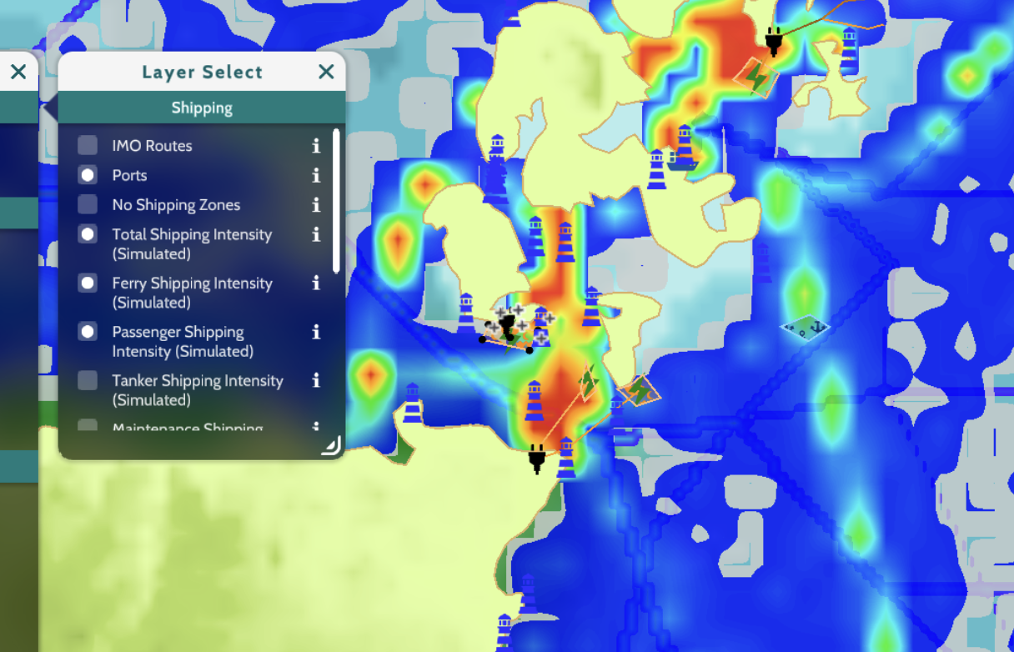Alternative 2, Shipping layer image: 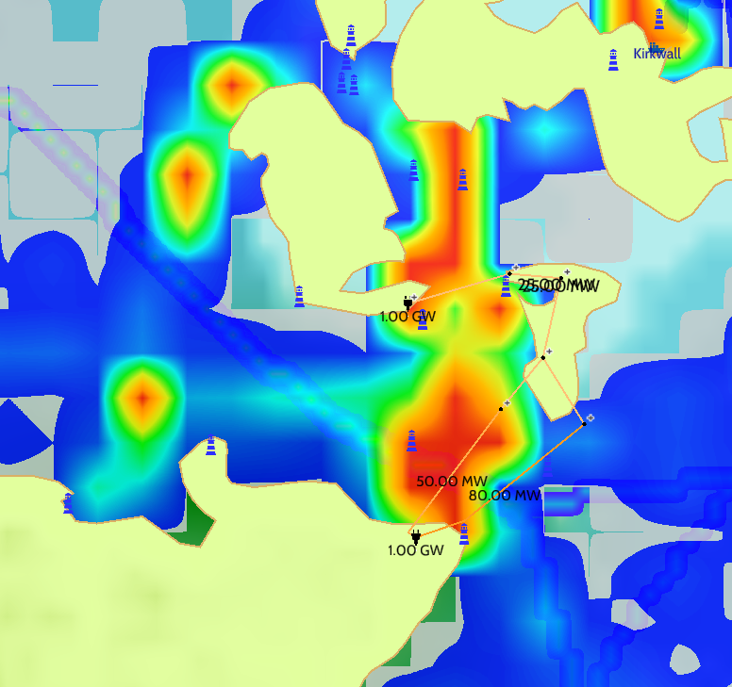

Effects on Marine Conditions Supporting Livelihoods

In addition to disrupting marine activities, the construction and presence of the cable can affect the environmental conditions that support local livelihoods. One concern is the availability of fish and shellfish. During installation, noise from vessels and machinery, along with seabed disturbance, may drive fish away from traditional fishing grounds. Activities like trenching, dredging, or rock placement can disrupt benthic habitats and temporarily reduce populations of species such as crabs and scallops (Marine Scotland, 2020). Increased turbidity from construction can also affect filter feeders and reduce visibility, which may alter feeding behaviour among fish.

Impact tool image for Alternative 1 and 2: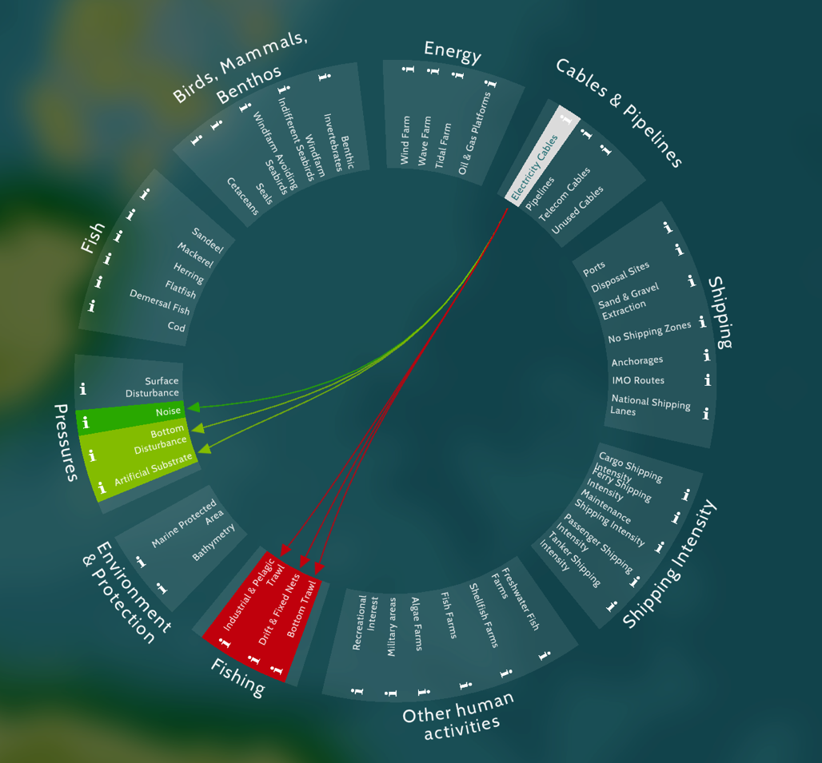

These environmental impacts are expected to be short-term if construction is phased and managed properly. However, the risk remains significant for fishers whose income depends on consistent conditions. Burial depth is another critical factor. If the cable is not properly trenched into the seabed, it may pose a hazard to fishing gear or boat anchors. Local fishers have emphasized the importance of ensuring the cable is buried deep enough to allow creeling and trawling to continue safely above it (SSEN Transmission, 2022). Project planners have identified areas with sufficient sediment depth to allow for burial, which helps reduce this risk.There are also concerns about how construction may affect wildlife that supports tourism and fishing. Temporary displacement of marine mammals such as seals and porpoises could reduce the appeal of wildlife tours. Fish spawning and nursery areas may also be affected by underwater noise or vibration. Once operational, the cable will emit low-level electromagnetic fields (EMF). While these are minor at 33 kV, species such as eels and some sharks are sensitive to EMF and may avoid areas close to the cable (Gill et al., 2020). While the effects are likely to be localized, they may still influence fishing success near the route and should be monitored.

Finally, temporary navigation risks must be considered. Cable-laying vessels, safety zones, and marker buoys can alter the flow of traffic and create short-term hazards for local mariners. Though the cable will not significantly affect tides or waves, small changes in the seabed—such as rock berms used to protect cable sections—can change how water moves in shallow or exposed areas.

Alternative 1, recreational layer image: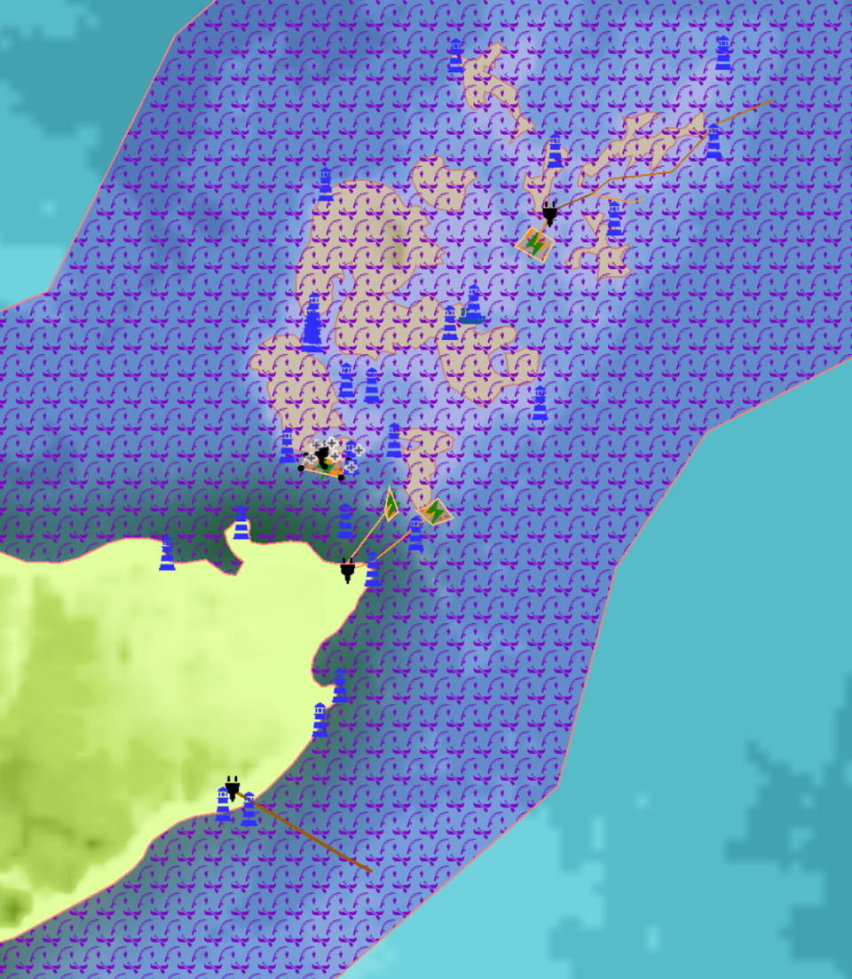

Alternative 2, recreational layer image: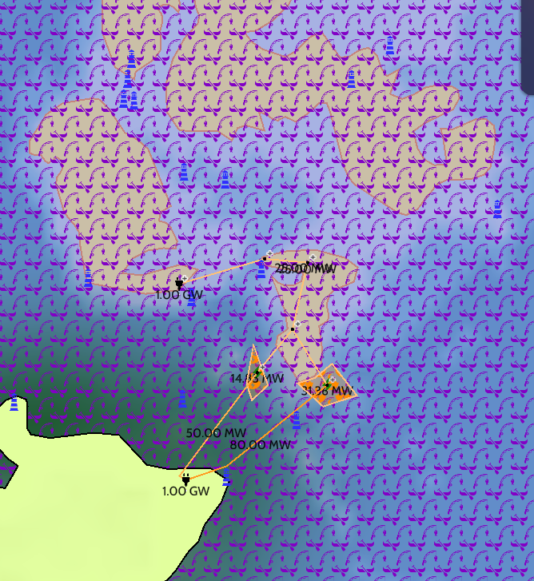

Community Trade-offs: Access, Safety & Daily Activities

The proposed cable route under Plan A introduces trade-offs that affect access to the sea, safety, and the rhythm of daily life on Hoy. During construction, certain areas may be temporarily closed or restricted. Fishing activity could be displaced, particularly where the route crosses scallop beds or creeling zones. Project vessels may limit where fishers can operate, and gear may need to be removed. Coastal access points such as piers, roads, or beaches near the landing site could also be affected while work is underway (SSEN Transmission, 2022).

Safety concerns arise both at sea and on land. Marine traffic will increase as cable-laying ships, barges, and support vessels operate near ferry routes and local harbours. These movements, along with exclusion zones, could interfere with routine navigation and require detours or delays. Onshore construction will involve heavy equipment and excavation activity, raising safety risks near roads, paths, or homes close to the cable landing area. These impacts are expected to be temporary but will require careful coordination with ferry operators and emergency services such as the RNLI (Marine Scotland, 2020).

Daily routines may also be affected by the presence of noise, restricted access, and construction visibility. Recreational uses—such as kayaking, diving, and wildlife watching—may be reduced during active phases of installation. Local events like fishing trips or regattas could be postponed or relocated. These short-term disruptions coincide with the introduction of longer-term changes. After construction, the cable may lead some fishers to avoid certain areas of the seabed, depending on cable burial depth and route visibility. While some of these changes are subtle, they affect how the marine environment is used and accessed.

Taken together, these trade-offs reflect a shift from temporary construction impacts to long-term alterations in marine space use. The findings suggest that while Plan A may improve infrastructure reliability, it also introduces meaningful disruptions to how the sea is used during construction and potentially afterward (SSEN Transmission, 2022; Marine Scotland, 2020).

High-Use or High-Value Marine Areas Requiring Caution

Specific areas require heightened caution during cable installation. These include:

Lyness and Longhope Harbours: ferry and emergency response hubs.

Ferry Routes: vital connections for daily life and commerce.

Traditional Fishing Grounds: particularly scallop beds near South Walls.

Environmental and Cultural Sites: such as Scapa Flow (SPA), RSPB reserves, and known wrecks of cultural importance.

Aquaculture Zones: including Pegal Bay, where water quality must be protected.

Avoiding peak seasons, routing around sensitive features, and using appropriate mitigation (e.g. silt curtains, guard vessels) are essential for minimizing harm.

Long-Term Benefits for Hoy Island Communities and How to Ensure Them

Plan A, the proposed energy cable linking Hoy to mainland Scotland, is expected to bring lasting improvements to local energy supply, community resilience, and long-term development. One of the most immediate benefits is greater energy reliability. The Orkney Islands, including Hoy, frequently experience severe weather—strong winds, storms, and heavy rain—that often lead to power outages. These outages can leave homes and public services without electricity for hours or even days, particularly when ferry delays or storm conditions make it difficult for repair crews to reach affected areas (The Orcadian, 2022; Ofcom, 2023). The region’s existing infrastructure, including older overhead lines exposed to the elements, is vulnerable to faults and difficult to maintain in remote locations.

Upgrading Hoy’s power link through Plan A would reduce the number and length of outages. For households, this means more stable electricity for heating, lighting, and communication—especially important during winter storms. For essential services such as clinics and schools, it ensures better continuity of operations. These improvements can be measured using indicators like reduced outage frequency, faster repair times, and improved service ratings.A stronger connection to the national grid also creates space for new opportunities. Hoy is already part of Orkney’s broader renewable energy effort, and a community wind farm is planned at Wee Fea. With the new cable in place, electricity generated on Hoy can be exported to the mainland. This increases the viability of the wind project and helps create a steady income stream that stays within the community. Publicly owned energy developments tend to bring more local benefit than external projects, as profits are more likely to be reinvested in services or infrastructure.

To better understand the potential for local growth, ArcGIS was used to examine economic activity in the area. The data shows that Hoy and other nearby areas have lower full-time employment levels compared to the Scottish mainland. This highlights the importance of projects that can provide stable jobs and support wider community goals. Plan A supports this by creating short-term construction jobs, longer-term maintenance roles, and enabling other projects—such as electric ferries, marine infrastructure, or small business growth—that depend on stable electricity.

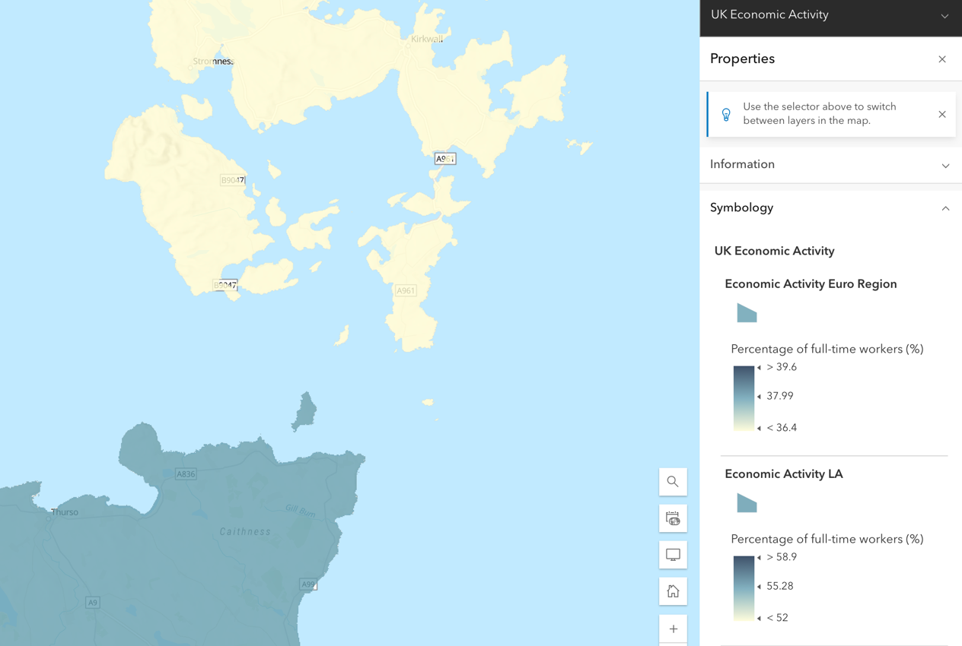

**Conservation representatives Perspective**

Using the MSP Challenge 2050 Simulator, we examined the spatial and ecological implications of the proposed tidal farm south of Hoy Island and its connecting cable route to Brims. The simulator’s geo-spatial tools enabled us to evaluate species distributions, critical habitat overlaps, and potential long-term consequences for marine ecosystems.

Our analysis draws on multiple geo-layers, including:

* Marine Mammals – identifying seal haul-out zones and cetacean activity
* Marine Protected Areas (MPAs) – particularly Special Protected Areas (SPAs) formerly under Natura 2000

* Fish Habitat and Sandeel Density – to assess food chain and spawning area sensitivity
* Macrobenthic Invertebrates – as indicators of seabed ecosystem health
* General Biodiversity – using composite ecological layers to identify high-density life zones

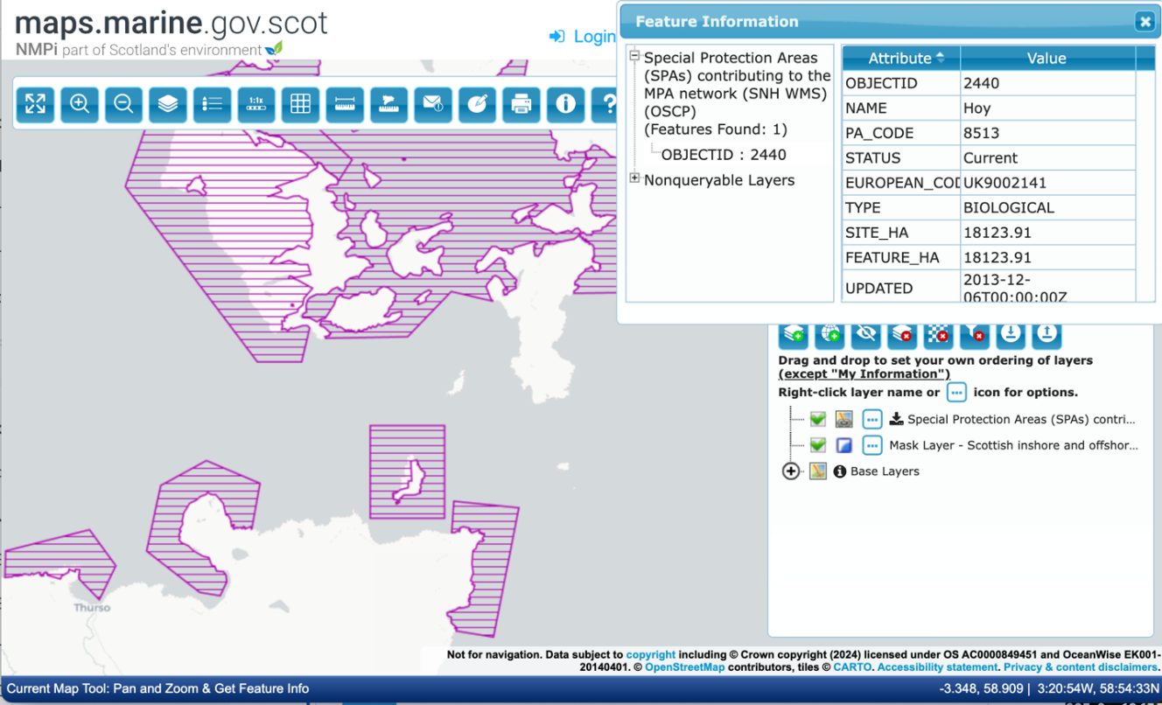

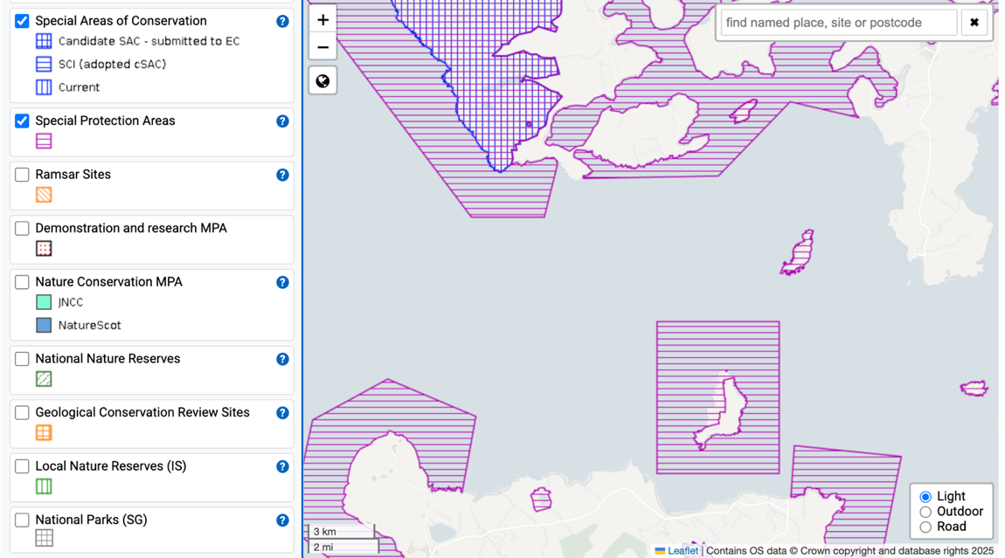

As of 2021, following the UK’s withdrawal from the EU, Special Protected Areas (SPAs) previously designated under the Natura 2000 network (EU state members) now fall under the UK National Site Network. The Brims SPA, adjacent to the proposed development zone, retains its high-protection status due to its role in supporting critical seabird colonies and marine mammals such as grey seals and harbour porpoises. Any development bordering this SPA must follow enhanced environmental scrutiny, particularly due to the presence of breeding and foraging zones.

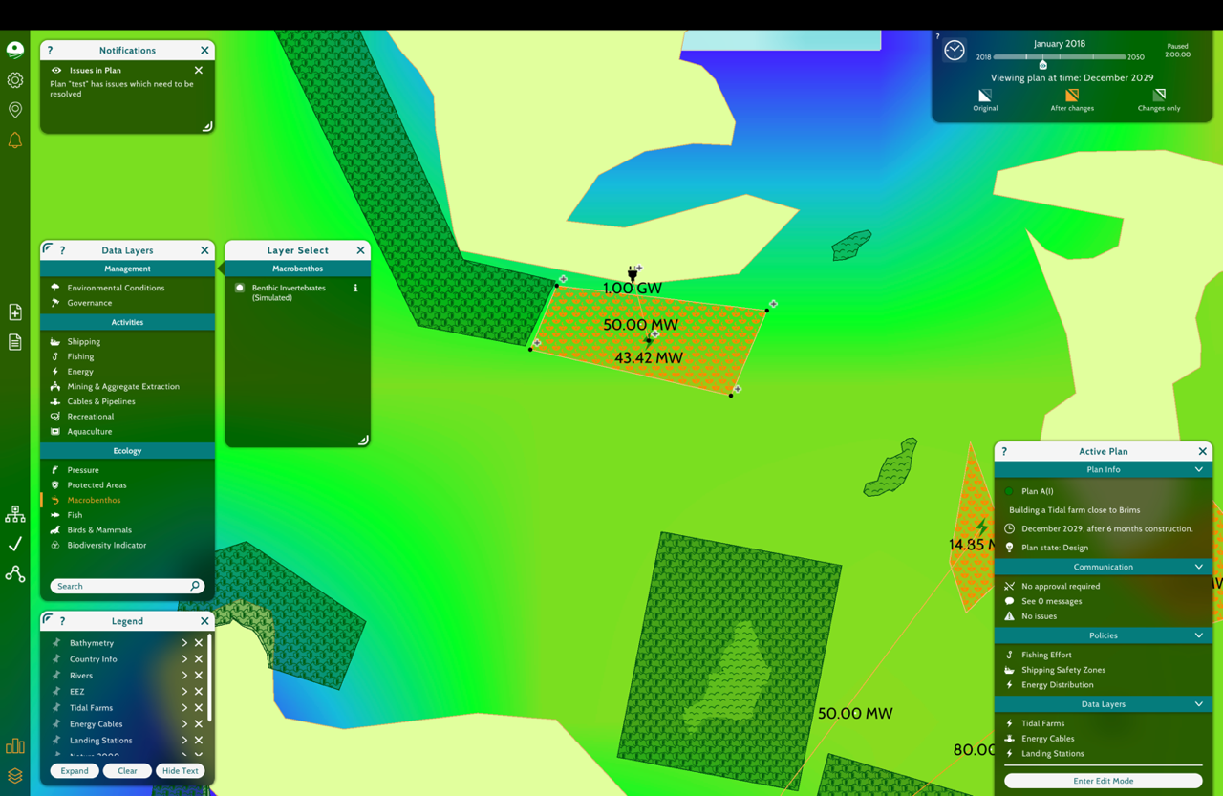

Alternate 1: Benthic Invertebrates

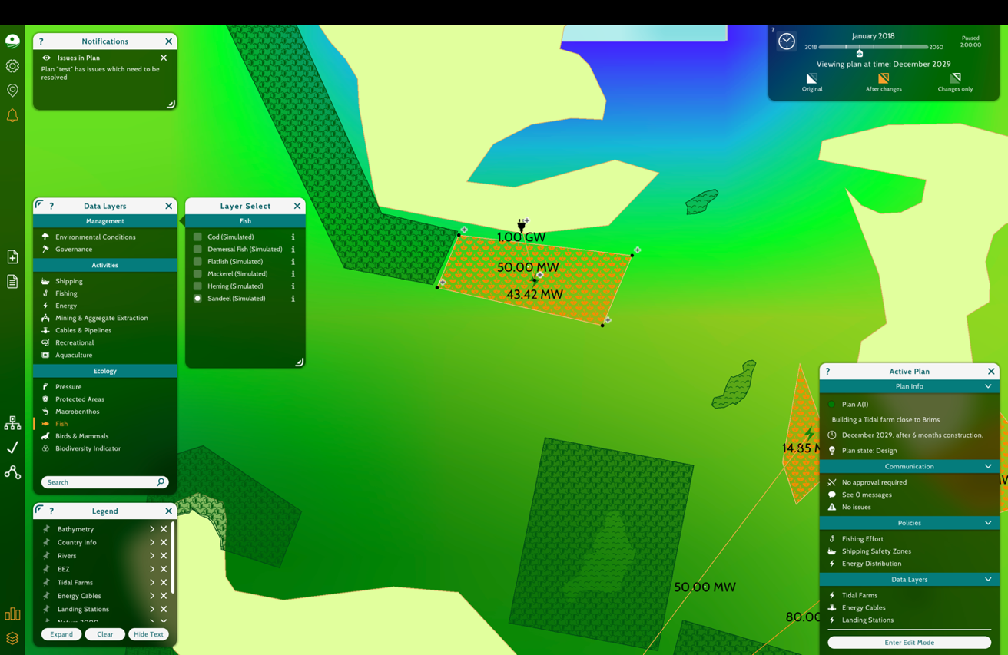

Alternate1: Sandeels

**Sandeels and benthic habita**t: Sandeel-rich zones may be disturbed by sediment plumes from trenching, impacting local food webs. Disturbance to benthic invertebrates could alter substrate stability and feeding grounds for demersal fish.

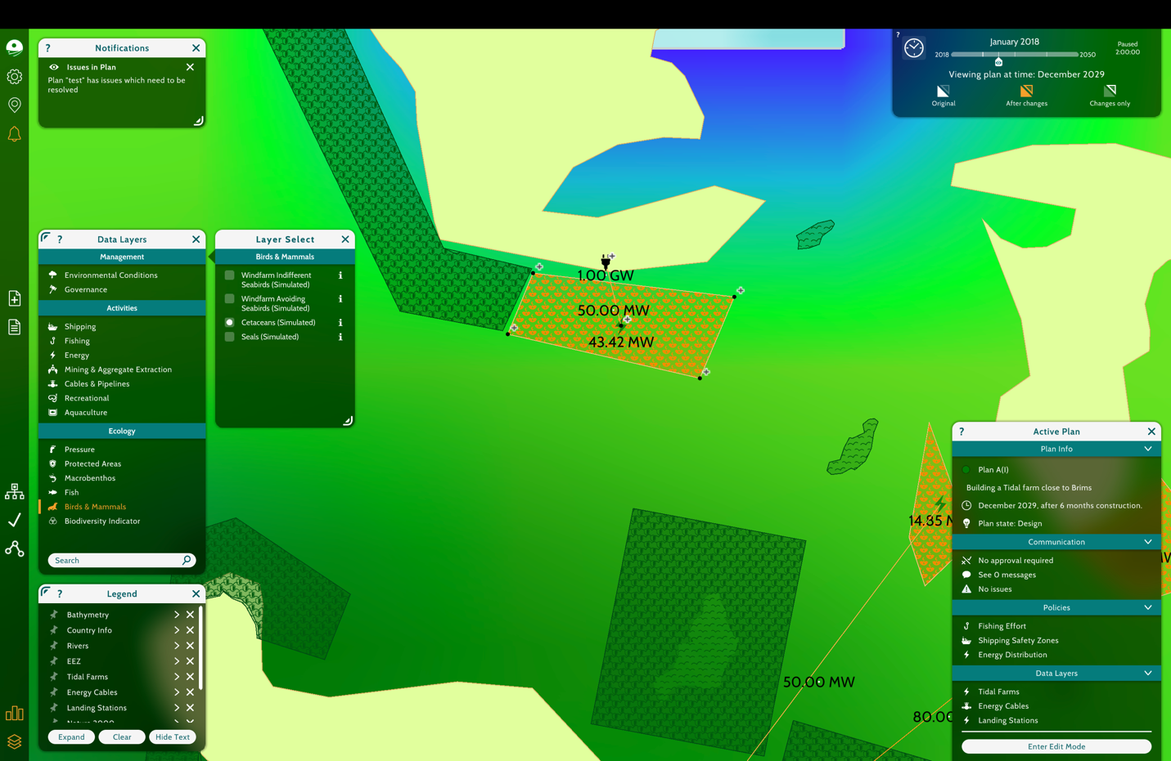Alternate 1: Cetaceans

**Cetaceans**: Moderate to high impact expected due to the acoustic sensitivity of species like porpoises and dolphins. Underwater noise can impair communication and navigation.

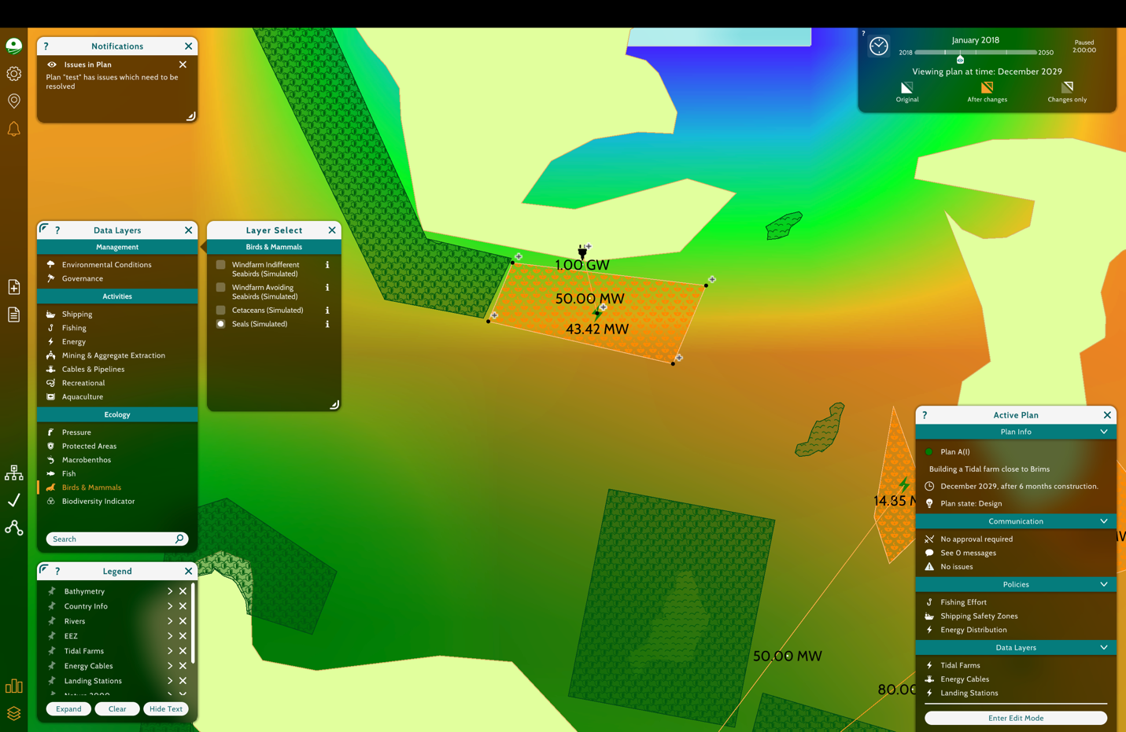Alternate 1: Seals

Very High to High Seal Density; Medium Seal Density; Low to Very Low Seal Density

**Seals**: The route passes near high-density seal zones, increasing the risk of noise disturbance during the breeding and pupping season. Construction-phase underwater noise and vessel traffic could cause stress or displacement. EMF (Electromagnetic Fields) may further disrupt foraging patterns.

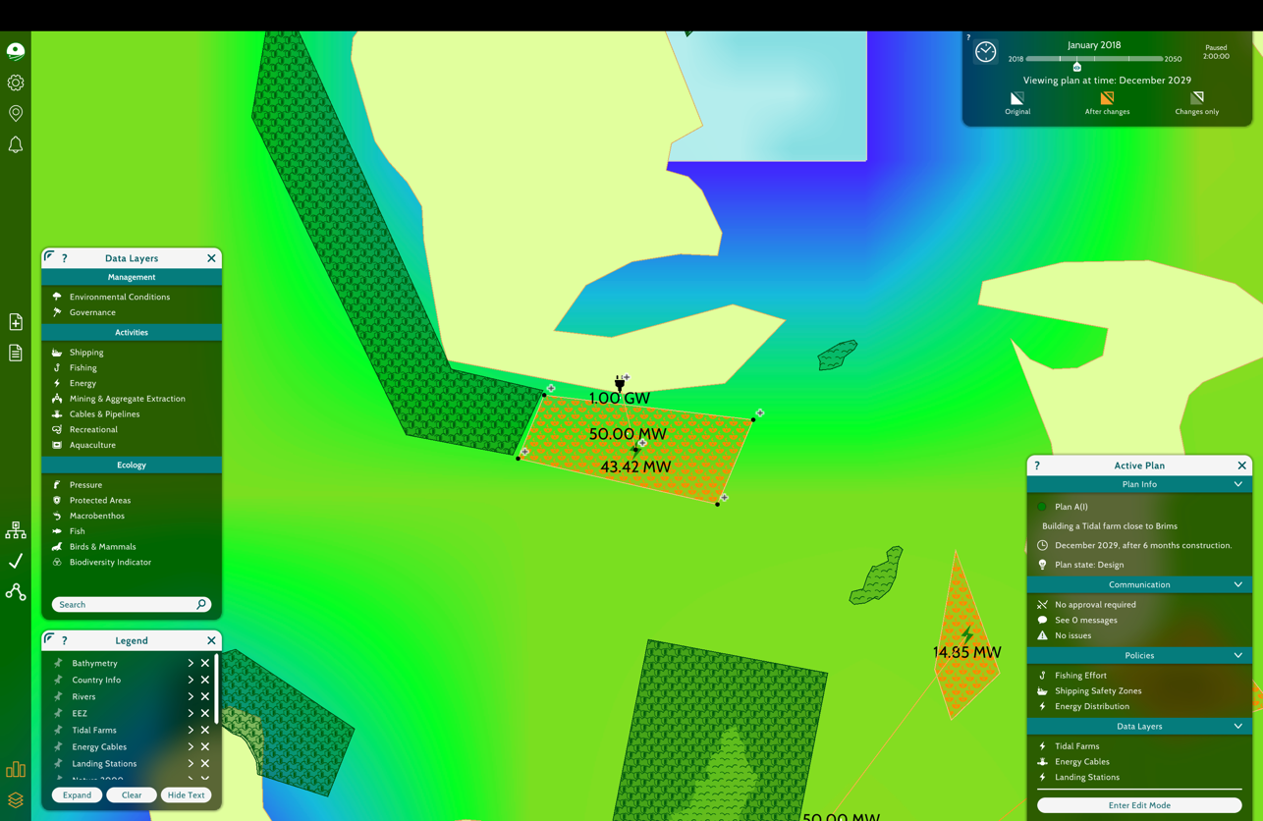

Alternate 1: Marine protected Areas

Based on combined data:

* Biodiversity Impact Rating: Moderate to High
* Especially within 1–2 nautical miles of the SPA where overlapping pressures (noise, EMF, seabed disruption) converge

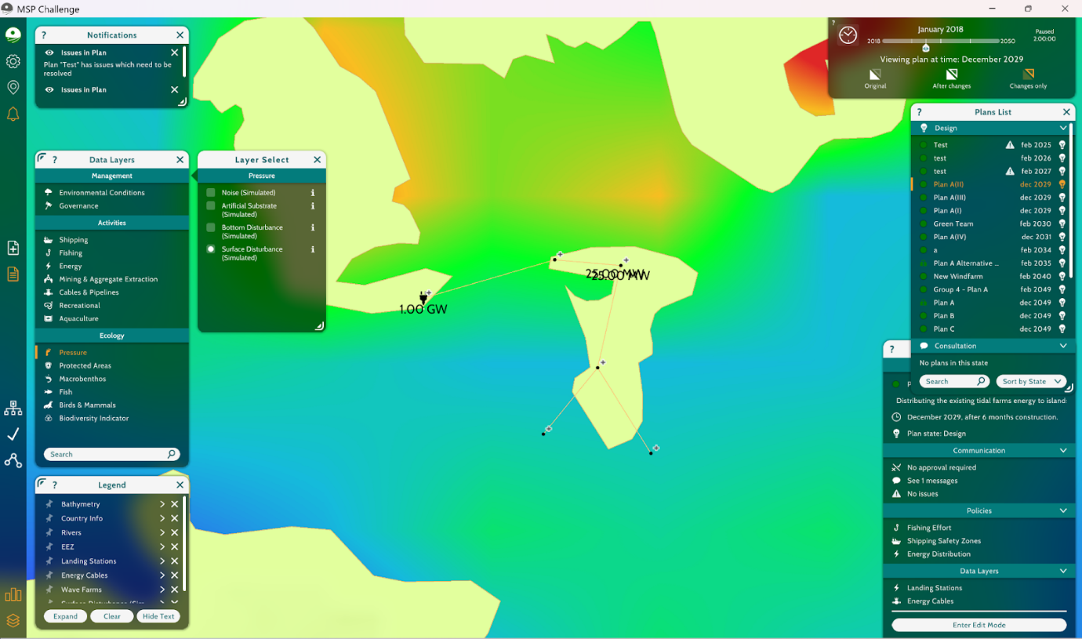

**Alternative 2: Visualization showing the surface disturbance level**

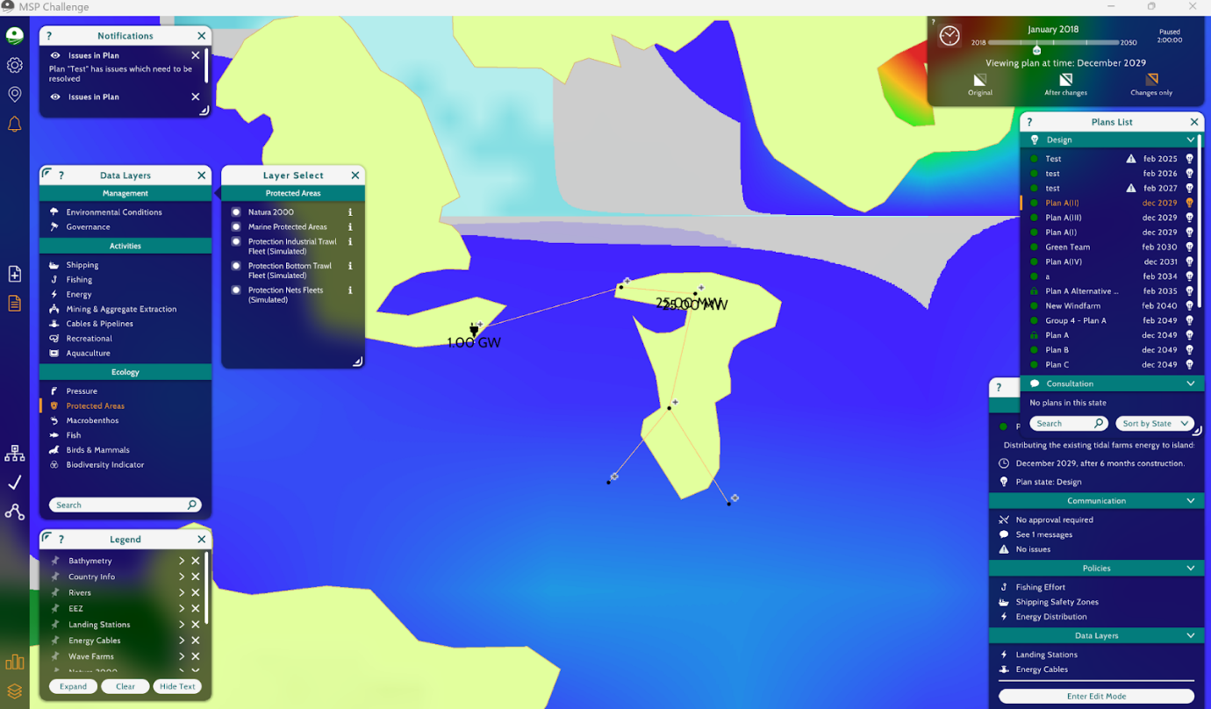

**Alternative 2: Ensuring no MPA or Special protected areas are passed**

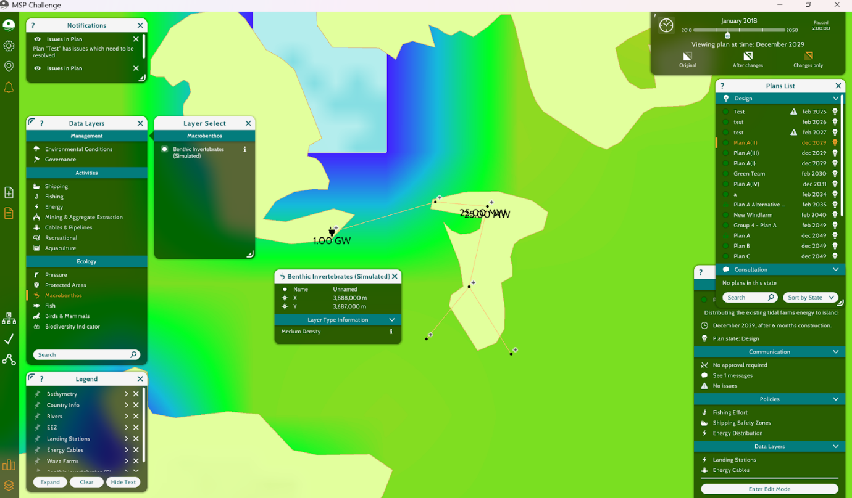

**Alternative 2: Benthic invertebrates such as crabs are at medium density here**

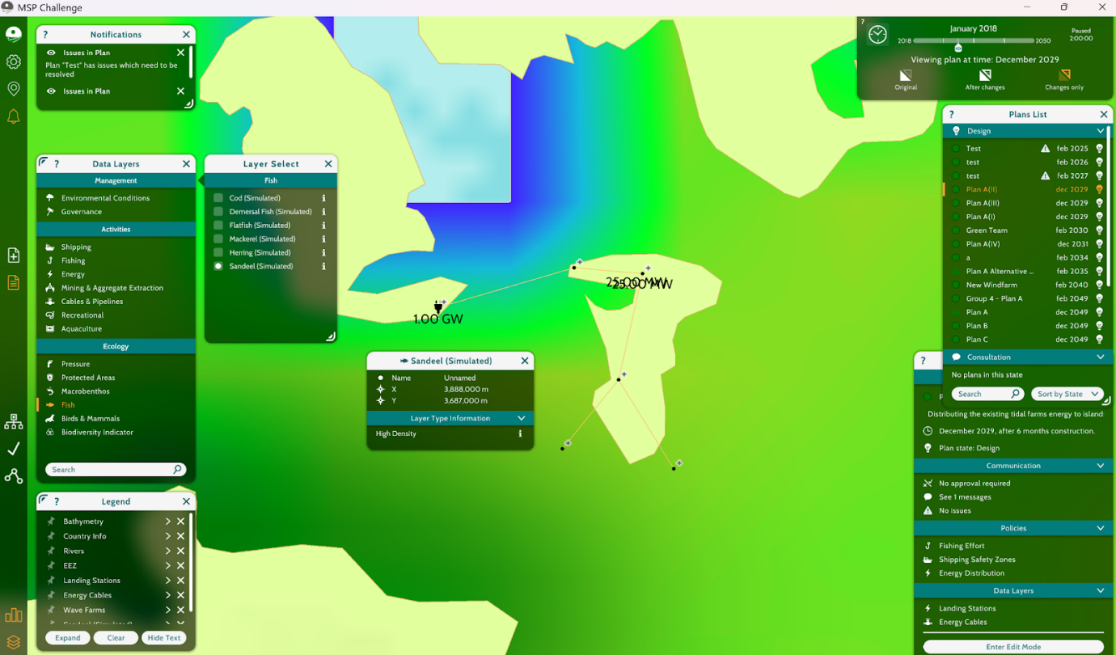

**Alternative 2: Sand eels were found to have the highest density among the fish group, while other fish, as shown, are at medium density.**

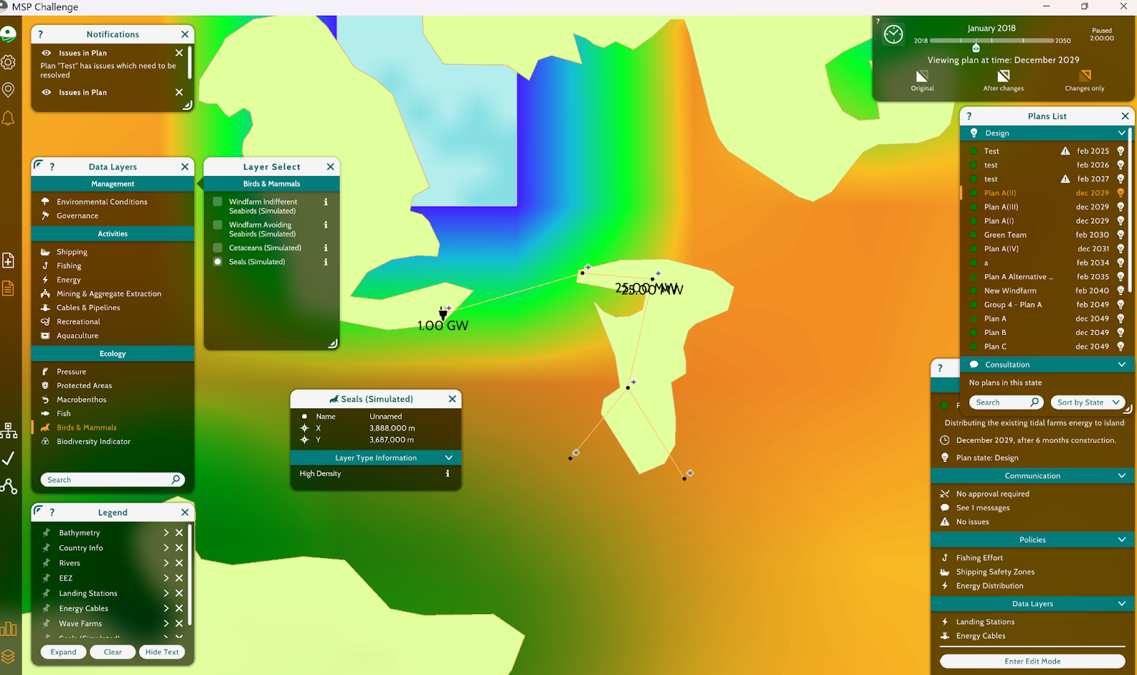

**Alternative 2: We have seals as our highest group of mammals around this area**

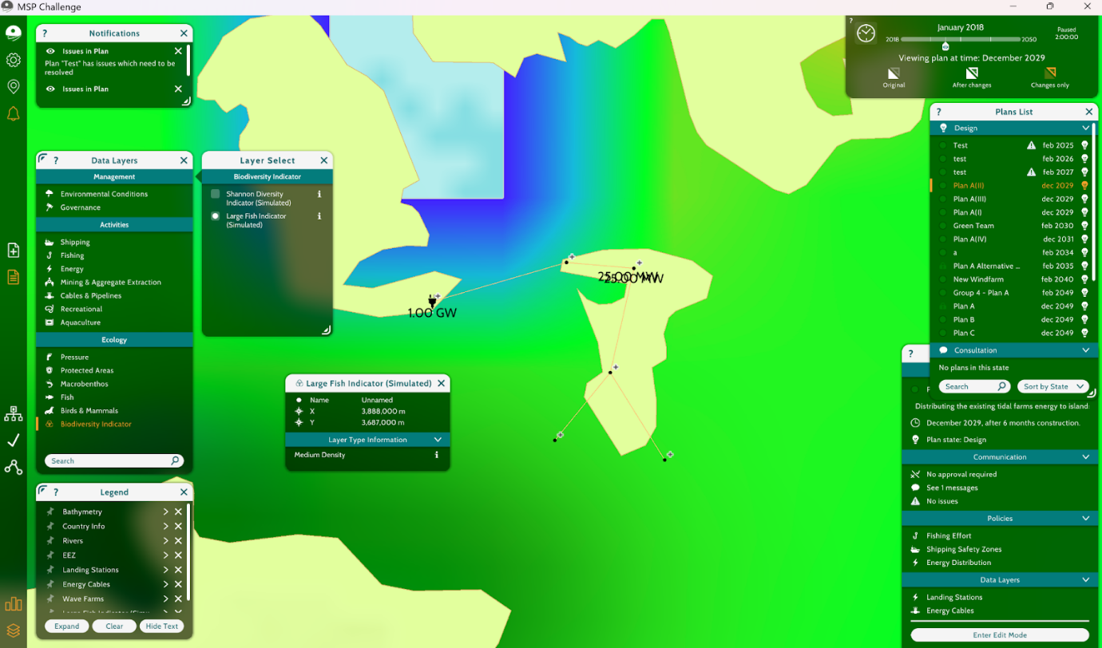

**Alternative 2: Confirming medium intensity of large fishes. According to biodiversity indicator**

We emphasize the need for ongoing ecological engagement throughout the project lifecycle:

* Pre-construction biodiversity mapping is essential to establish accurate baseline conditions
* Real-time ecological monitoring using drone footage, hydrophones, and satellite-tagged marine mammals can reduce unintended harm
* Post-installation surveys must assess:
* Seal and fish population recovery
* Noise and EMF zones using hydroacoustic analysis
* Substrate regeneration in trenched areas

Our findings advocate for a transparent environmental reporting process, in collaboration with Scottish Natural Heritage, Marine Scotland, and local conservation NGOs, to ensure full lifecycle accountability.

**REFLECTION:**

**MSP Challenge SIMULATOR: PLATFORM SPECIFIC QUESTIONS:**

**REFLECTION QUESTION 1: What were some of the challenges and considerations you faced when deciding on a location for and implementing your offshore wind farm plan?**

Group 4: One of the major challenges was avoiding disruption to heavily used marine areas such as fishing grounds, ferry routes, and recreational zones. As a community focused group, we had to prioritize minimizing interference with daily marine activities, which meant navigating around densely used coastal areas. We also had to consider how installation might impact safe boat access, particularly for small-scale fishers. The cable had to connect key substations, but not at the cost of undermining local livelihoods or safety.

Group 5: As Conservationists, our greatest challenge was balancing the environmental protection of designated Special Protected Areas (SPAs), like Hoy SPA, against the need for renewable energy development. One critical consideration was the proximity of the tidal farm to Natura 2000-designated zones, which demanded caution due to the presence of sensitive species like seals and seabirds. Data layers revealed medium to high biodiversity zones, which narrowed viable installation areas. Additionally, potential impacts from noise pollution, EMF radiation, and sediment disruption required rigorous analysis of marine mammal and sandeel densities. Our decision-making was not only constrained spatially but also temporally—we had to avoid seal breeding and pupping seasons to minimize harm. The simulator’s visual data layers helped reveal overlaps and allowed for real-time strategy adjustments, but the complexity of these trade-offs required nuanced judgment.

Group 6: As a group, one of the key challenges we faced in selecting a location for offshore energy development specifically in the context of wave or tidal energy, though applicable to wind as well was balancing technical feasibility with environmental protection. Navigating around Marine Protected Areas (MPAs), active fishing zones, and shipping lanes required a delicate trade-off between ecological integrity and project efficiency. Additionally, seabed characteristics whether mixed sediment, hard substrate, or uncategorized directly influenced the cost and complexity of cable routing and anchoring systems. Regulatory uncertainties around proximity to conservation zones and the potential opposition from stakeholder groups, such as fishers and conservationists, added further complexity. Implementing a plan meant thoroughly analyzing not only the natural geography but also the socio-political landscape, ensuring that all concerns were accounted for in the planning phase.

**REFLECTION QUESTION 2: Generally, what sort of criteria might you use to evaluate whether an issue must be resolved, or whether it can be ignored during plan implementation? Consider the incompatibility of certain activities that do not actually prevent the plan from being approved (artificial substrate arising from cables reduces the ecological integrity of a Marine Protected Area, but can exist in MPAs, in some cases).**

Group 4: We prioritized issues based on community impact severity. If a proposed cable route threatened access to traditional fishing zones, navigational safety, or economically vital marine areas, we treated it as essential to resolve. Lesser impacts, such as minimal interaction with areas of moderate recreational interest, were noted but considered manageable if accompanied by strong mitigation strategies. Our guiding principle was to protect the spaces that local people rely on most.

Group 5: The criteria we applied stemmed from impact intensity, stakeholder sensitivity, and legal obligations. For example, while artificial substrates from cables may technically be permitted within some MPAs, if such substrates degraded habitat integrity for benthic organisms or disrupted seal haul-outs, we deemed them unresolved issues requiring mitigation. We prioritized issues based on a matrix of legal constraints (e.g., SPA protection laws), ecological importance (e.g., species density), and reversibility. An issue like temporary turbidity could be tolerated if it fell within seasonal windows and recovery was likely, but noise pollution affecting breeding marine mammals was non-negotiable. Long-term, cumulative ecological damage also played a role in whether an issue was considered “critical” or “tolerable.”

Group 6: When deciding whether an issue must be resolved or can be deprioritized, we considered several factors. The most important criteria were: (1) whether the issue posed a **legal or regulatory barrier** (such as direct interference with a designated MPA), (2) whether it affected **core stakeholder interests** (e.g., disruption of high-density fishing grounds or essential shipping corridors), and (3) whether it posed a **long-term operational or environmental risk** to the success of the project. For instance, a minor ecological trade-off—such as artificial substrates from cables—might be acceptable within an MPA if it does not fundamentally undermine biodiversity goals or if it can be mitigated. In contrast, a route through a heavily trafficked shipping lane would pose a serious safety issue and would likely halt the plan. Therefore, decisions hinged on evaluating **risk magnitude, stakeholder sensitivity, and legal constraints**.

**REFLECTION QUESTION 3: Who is missing from the table when deciding whether to approve plans? What additional information do you think broader groups would want to know if, and when, approving your marine plan?**

Group 4: Local coastal communities, particularly fishers and small scale operators, are often underrepresented in these planning processes. They bring critical local knowledge but may not have a formal seat at the table. Broader groups would likely want more transparency about timelines, exclusion zones, compensation structures, and how construction will be timed to avoid peak activity seasons. They’d also want to know how their input will be used, not just heard.

Group 5: Local Indigenous communities, tourism operators, and independent ecological researchers were notably underrepresented. These groups hold vital knowledge of local biodiversity patterns and cultural values tied to marine space. A marine plan of this scale must consider traditional ecological knowledge, particularly for intertidal zones and foraging paths not captured by generic data layers. Broader groups—especially regulators, advocacy organizations, and coastal residents—would also want longitudinal data on post-installation recovery, baseline ecosystem health, and adaptive monitoring strategies. Real-time sensor data for noise, turbidity, and mammal migration would significantly bolster stakeholder confidence in the plan’s integrity and feasibility.

Group 6: In our planning simulation, key stakeholder groups were represented, including developers, conservationists, and local communities. However, national policymakers, marine scientists, indigenous groups, and emergency services or maritime navigation authorities were notably absent. These broader groups could provide critical perspectives on long-term policy alignment, cultural heritage impacts, marine safety, and scientific monitoring. Additional information they would likely request includes projected carbon savings, lifecycle environmental impact assessments, job creation data, contingency planning in case of equipment failure, and the potential for co-use of marine space (e.g., shared fisheries and renewables). Including these voices would contribute to a more holistic and transparent marine governance process.

**REFLECTION QUESTION 4: How would you prioritize between the implementation of marine protected areas or the development of offshore wind farms, as the primary activity in your country’s waters? What considerations would you give to choosing which activity to rely more heavily on, if one more than the other? How could this information be helpful in making a business decision?**

Group 4: We would prioritize marine protected areas in zones where biodiversity or community use is high. However, we support energy development when it is done responsibly. The decision must consider long-term ecosystem health, community impact, and whether cable routes can be adjusted to avoid sensitive areas. From a business angle, respecting MPAs and community zones can reduce opposition, delays, and reputational risks, making the project more viable and socially acceptable.

Group 5: We would prioritize the implementation of marine protected areas unless a renewable energy project demonstrates low ecological risk and high mitigation success. Protected areas offer long-term ecological services—carbon sequestration, fish stock renewal, storm buffering—that indirectly support sustainable economies. However, if wind farms can be strategically located outside high-sensitivity zones and include robust ecological monitoring, they can be compatible with MPA goals. In business terms, this data enables predictive cost modeling—e.g., the financial cost of environmental lawsuits or regulatory delays versus the cost of route adjustments or seasonal timing. The trade-off matrix helps us project ROI not just financially but socially and ecologically.

Group 6: As a group, we recognize the importance of both marine conservation and renewable energy development. However, if prioritization were required, we would weigh **urgency of climate goals** against **ecological vulnerability**. In regions where biodiversity is irreplaceable or species are endangered, MPAs must take precedence. In areas where marine habitats are resilient and energy needs are urgent, offshore renewables might be prioritized—provided they follow strict environmental standards. The key is **zoning smartly**, identifying spaces where these priorities can coexist or complement each other. From a business perspective, understanding this balance helps forecast **permitting risks**, **community acceptance**, and **policy alignment**, all of which are critical for investment security and long-term returns.

**REFLECTION QUESTION 5: What opportunities or challenges exist for using MSP Challenge 2050 as a marine spatial planning tool? How has the MSP program helped develop your understanding of learnings about the use of analysis to support stakeholder consultation in implementing large development projects? How could the MSP Simulator be improved to help even further?**

Group 4: The simulator was an excellent tool for understanding the complexity of multi stakeholder planning. It helped us develop skills in layer analysis, conflict resolution, and spatial negotiation. A challenge was the limited integration of community voices as interactive components. For further improvement, adding community sentiment overlays, cost impact models, or dialogue simulations would help users better practice stakeholder engagement — especially in projects where social license is crucial.

Group 5: MSP Challenge 2050 provided a sandbox for learning how spatial conflicts emerge across stakeholder interests and how data can resolve—or complicate—those conflicts. It highlighted the importance of multi-layered analysis in reconciling biodiversity with infrastructure development. The biggest opportunity was seeing stakeholder perspectives visualized through geo-layers, allowing for more empathetic and evidence-based negotiation. One limitation was the lack of real-time cost analysis or dynamic policy feedback, such as fines or compensation costs tied to high-impact decisions. Including AI-powered predictive tools for environmental impact or economic modeling would significantly enhance the simulator’s utility for future analysts.

Group 6: The **MSP Challenge 2050 simulation** offered a powerful and immersive learning experience that helped us grasp the complexity of marine spatial planning. One key opportunity is its ability to visualize conflicts between layers such as fisheries, MPAs, and cable routes enabling better spatial judgment and planning accuracy. It allowed us to test real-world trade-offs and experience the negotiation process firsthand. However, challenges included limited cost modeling, lack of real-time stakeholder reactions, and static environmental risk metrics. To improve the tool further, we suggest integrating **financial simulations**, **dynamic ecological feedback**, and **AI-driven stakeholder roleplay** to simulate negotiations more realistically. Overall, the MSP simulator helped us appreciate how analysis, when combined with inclusive stakeholder engagement, drives better and more sustainable decisions in marine planning.

**BUSINESS MANAGER ROLE SPECIFIC REFLECTION QUESTIONS:**

**1. Did this assignment help you develop new perspectives when applying these skills in business?**

Group 4: Yes. It showed us how social and environmental data must guide business feasibility. In planning or infrastructure development, understanding stakeholder concerns and spatial conflict is key to designing sustainable and resilient solutions. This project built our capacity to assess risk from a community and compliance lens.

Group 5: Absolutely. It sharpened our understanding of how environmental data, stakeholder pressure, and regulatory frameworks shape business feasibility. In business settings, especially in sustainability or ESG strategy, similar multi-criteria decision models are critical.

Group 6: Yes, this assignment helped us develop new perspectives on how spatial data, stakeholder interests, and technical feasibility converge in business decision-making. It reinforced the importance of sustainability and environmental impact in infrastructure planning and taught us how these factors influence business strategies beyond just cost and efficiency.

**2. Did you use a specific approach in developing your executive analysis and discuss various points over the other possible alternatives of how you determined the way to define your understanding to this assignment?**

Group 4: We considered ecological sensitivity, the intensity of marine usage, stakeholder pressure, and regulatory concerns using a decision matrix technique. Depending on whether a route exceeded acceptable effect criteria, it was screened. We were able to transparently and substantially support our final recommendation thanks to this methodical approach.

Group 5: Yes, we used a decision matrix that weighted ecological sensitivity, spatial overlap, stakeholder pressure, and regulatory constraints. Alternatives were evaluated against this framework, and only those routes that passed the environmental feasibility threshold were shortlisted.

Group 6: We followed a Structured Decision-Making (SDM) approach. This helped us define clear objectives, evaluate trade-offs among alternatives, and build a logical framework to compare plans. We also made sure to consider both quantitative and qualitative aspects before finalizing our executive analysis.

**3. How did any other outside sources/data affect your decision-making?**

Group 4: We included external information such reports on marine traffic safety, studies on cable-induced electromagnetic impacts, and UK Special Protection Area (SPA) rules. These gave us more background information to back up the simulator data, which enabled us to make sensible and practical planning choices.

Group 5: Beyond the MSP Simulator, we reviewed conservation policies for SPAs under UK law, academic studies on EMF impacts on marine life, and marine mammal behavior data. This external information helped ground our assumptions and validate spatial insights from the simulator.

Group 6: External sources like the Marine Scotland Data Portal, EMEC (European Marine Energy Centre), the Isle of Eigg case study, and ongoing projects such as MeyGen provided valuable insights. These helped us validate the feasibility of tidal and wave energy, understand the implications of Marine Protected Areas, and assess energy independence models effectively.

**4. What were your main assumptions and decision and why?**

Group 4: We assumed that direct disruption to high-use community areas (fishing, transport, recreation) was unacceptable. We also assumed that impacts could be minimized through seasonal timing and partial rerouting. Lastly, we operated on the belief that communities must be active partners in planning, not passive observers.

Group 5: We assumed that minimizing harm to key species—seals, cetaceans, and sand eels—was non-negotiable. We also assumed that ecological recovery post-installation was likely if construction avoided breeding seasons and habitats were not irreversibly altered.

Group 6: Our primary assumption was that long-term environmental protection, energy independence, and minimal stakeholder conflict were just as important as technical and financial factors. This guided our decision-making and led us to choose Alternative 3, which avoided ecologically sensitive areas while providing a sustainable, community-driven energy source.

**5. What were your top three strategies, as a group, to decide on the geo-layers/areas you selected in the simulator?**

Group 4: Overlap Analysis: Avoided routes that intersected multiple layers of community or environmental use.

Timing Considerations: Factored in seasonal marine activity to avoid peak use periods.

Route Adjustments: Prioritized cable paths that could be shifted slightly to reduce high-impact interactions.

Group 5: Overlap analysis – identifying areas with layered conflict (e.g., high mammal density + proximity to SPA).

Temporal sensitivity mapping – using seasonal filters to guide timing of installations.

Mitigation modeling – choosing locations where minimal adjustment would yield significant ecological protection.

Group 6: First, we prioritized environmental constraints by avoiding Marine Protected Areas. Second, we looked for minimal interference with fishing zones and shipping routes. Third, we assessed the seabed type and distance to determine infrastructure complexity. These criteria shaped our selection of both cable routes and generation sites.

**6. Explain how you arrive at your project solution as a group of stakeholders putting your heads together.**

Group 4: We used a negotiation mindset, combining our community focus with simulated input from developers and conservationists. We worked collaboratively to propose adjustments, rather than total rejections, allowing for progress that respected both energy goals and community well-being.

Group 5: We led with the conservation lens but simulated conversations with developers and community members using stakeholder statements and data. This gave us insight into economic pressures and allowed for compromises (e.g., shifting routes slightly instead of full rejections).

Group 6: We simulated a stakeholder meeting involving Developers, Conservationists, and Community Representatives. Each group presented their concerns and goals. Through structured dialogue and compromise, we collectively concluded that Alternative 3 offered the best trade-off balancing technical viability, environmental protection, and community benefit.

**7. What was your understanding, experiences, opinions, lessons learnt and key takeaways from this assignment? - Briefly explain.**

Group 4: We learned that technical solutions aren’t enough, true feasibility includes community trust, clear communication, and spatial fairness. The assignment showed us how planners and businesses must use tools like MSP not just to plan infrastructure, but to plan it ethically and inclusively.

Group 5: This project taught us that data alone doesn’t solve conflicts—interpretation, stakeholder framing, and negotiation matter just as much. As aspiring analysts, the MSP Challenge reinforced the need for ethical foresight, spatial literacy, and transparency in our recommendations.

Group 6: We gained a deeper understanding of how multi-criteria decision-making works in real-world energy planning. The assignment improved our analytical, strategic, and collaborative skills. We learned that successful planning isn’t just about technical correctness it’s also about earning community trust and respecting ecological boundaries.

**8. Provide feedback or any additional information you would like to share.**

Group 4: The simulator was a valuable learning tool. To enhance future versions, we suggest adding modules for real-time stakeholder feedback, economic trade-off modeling, and policy enforcement simulation. This would give students a more complete picture of how marine development unfolds.

Group 5: The MSP Simulator was an exceptional tool to simulate high-stakes, real-world decisions. However, a stronger integration with economic or legislative outcome modeling (such as carbon offset crediting, or fines for biodiversity violations) would enhance its realism. Adding stakeholder negotiation scenarios with branching dialogues could also improve the educational experience.

Group 6: This was one of the most hands-on and engaging projects we've done. It simulated a real-world challenge with practical implications and required cross-disciplinary thinking. The integration of stakeholder roles helped us appreciate different perspectives and highlighted how complex yet rewarding collaborative planning can be.